HANDBOOK

COLD VENTILATED FUNCTIONS:
COLD VENTILATED WELL
COLD VENTILATED WELL WITH GLASS SHELF
COLD VENTILATED DISPLAY
COLD VENTILATED DISPLAY COMPACT
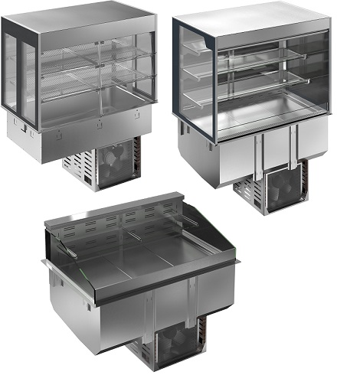

Installation diagram
See the specific sheet included in the documentation of this product.
Installation design suggestion (only for drop-in)
See the specific sheet included in the documentation of this product.
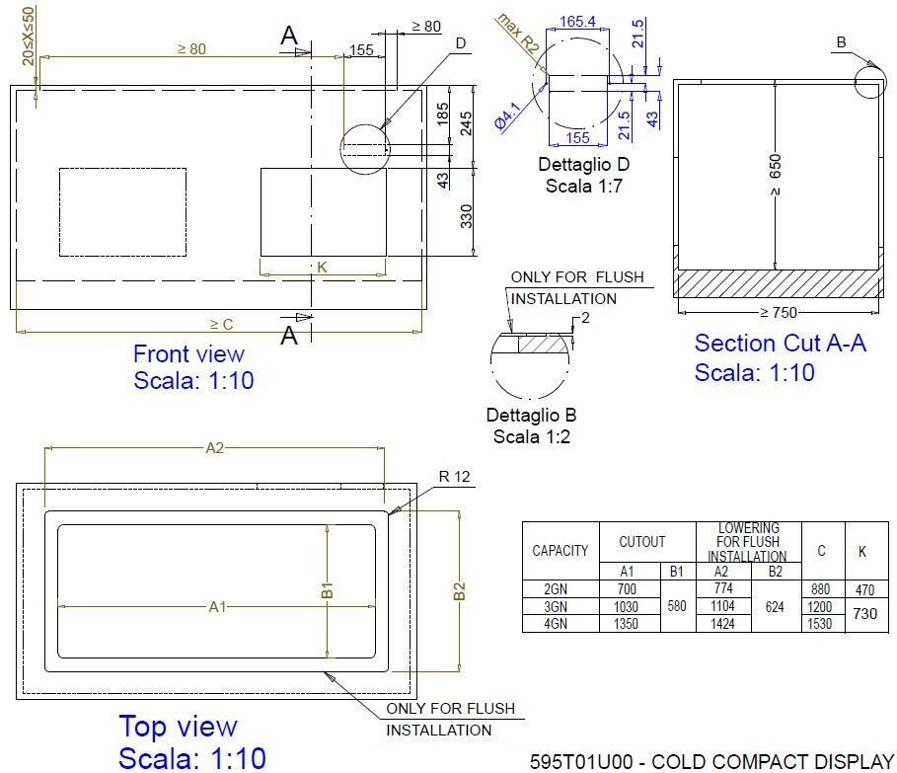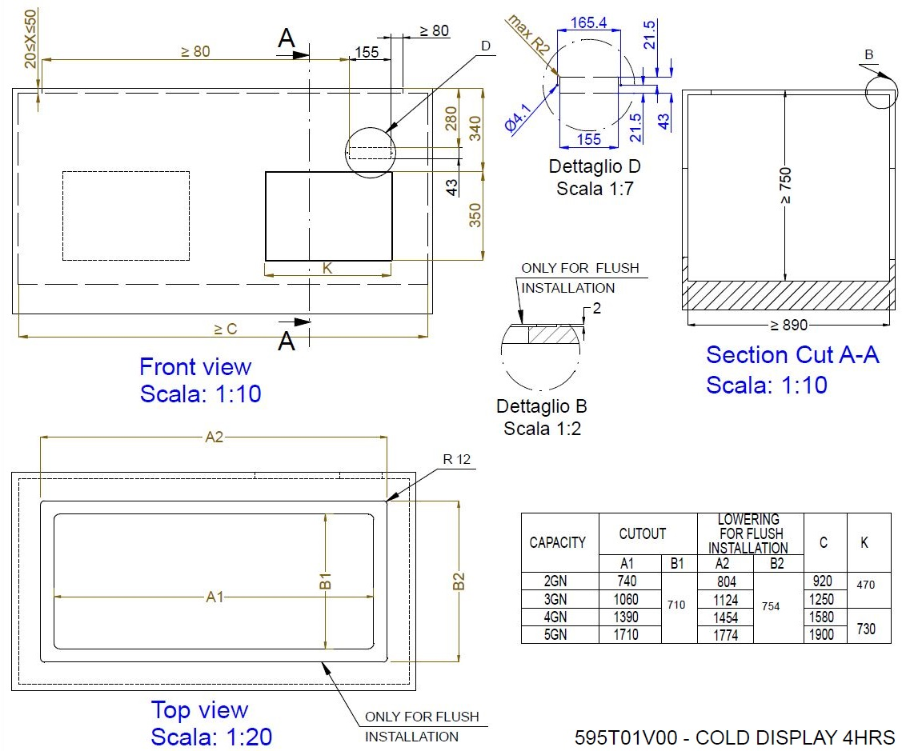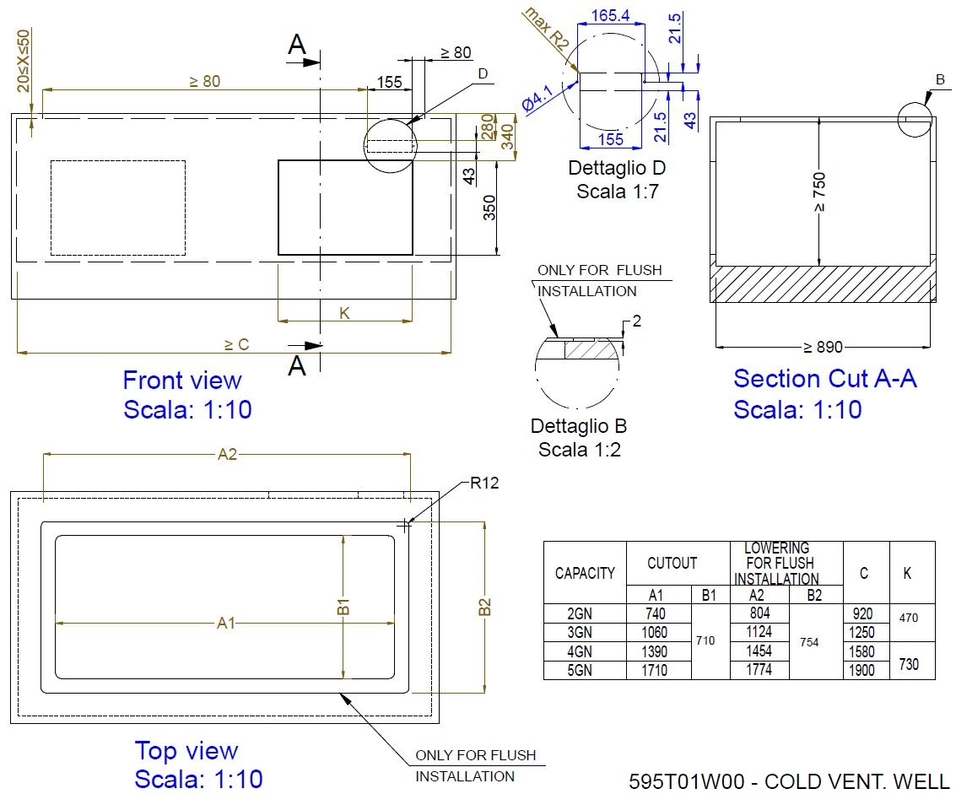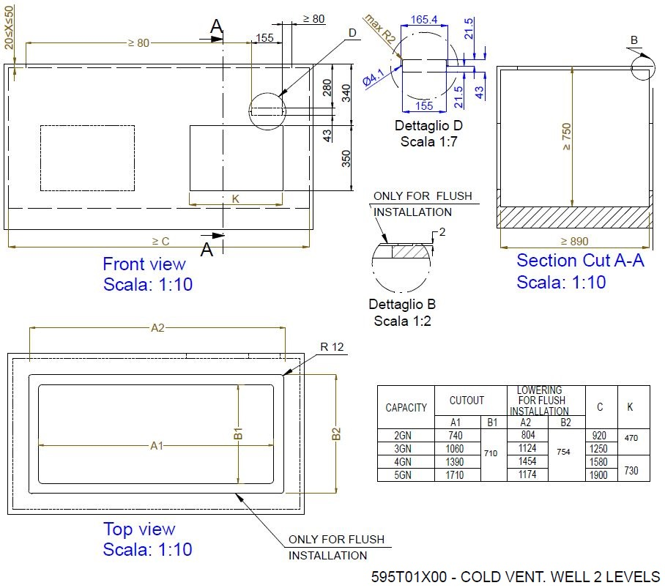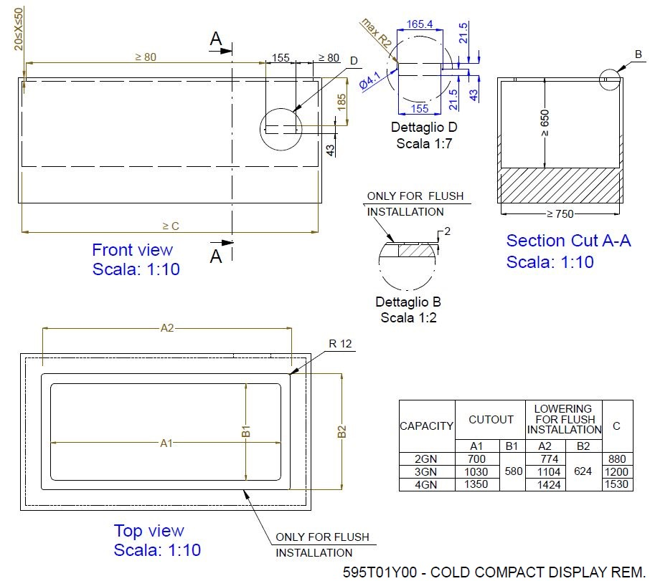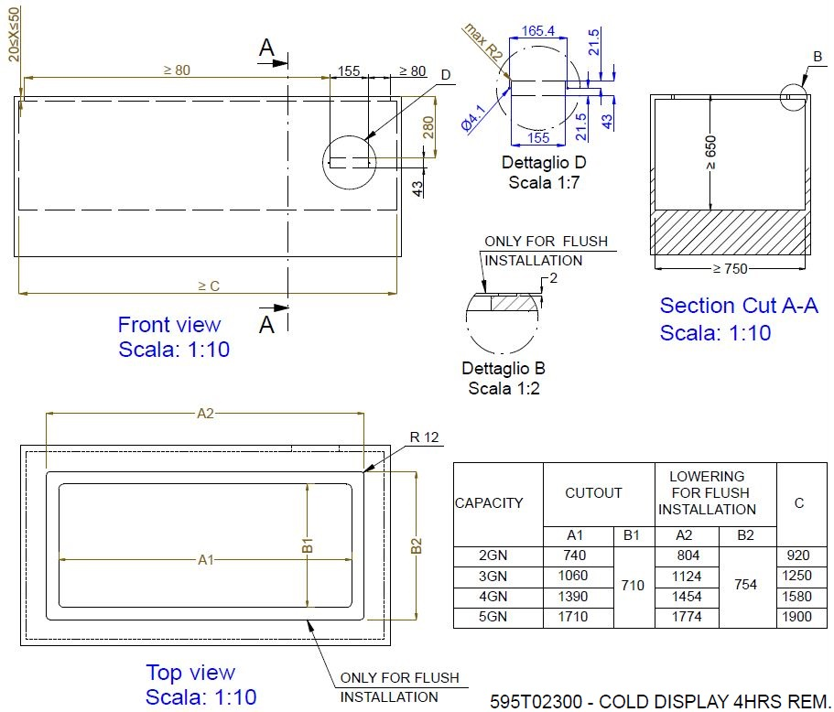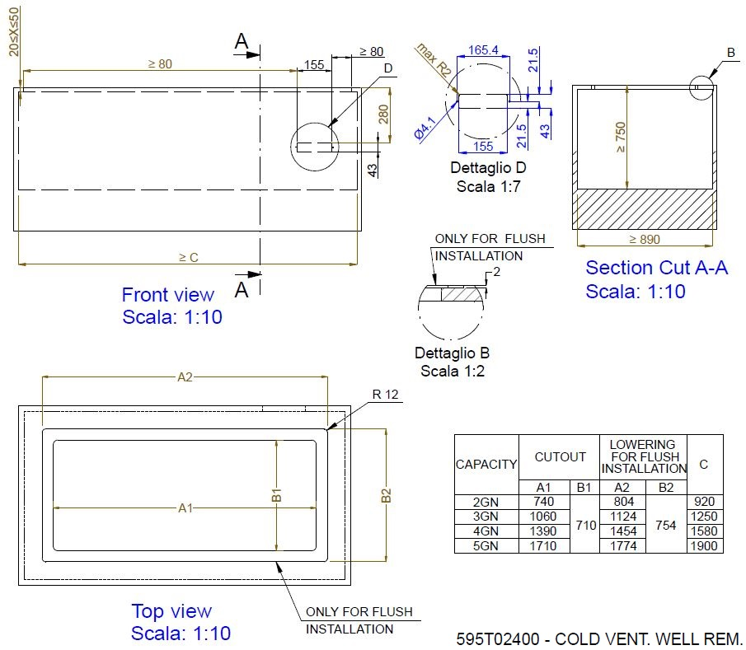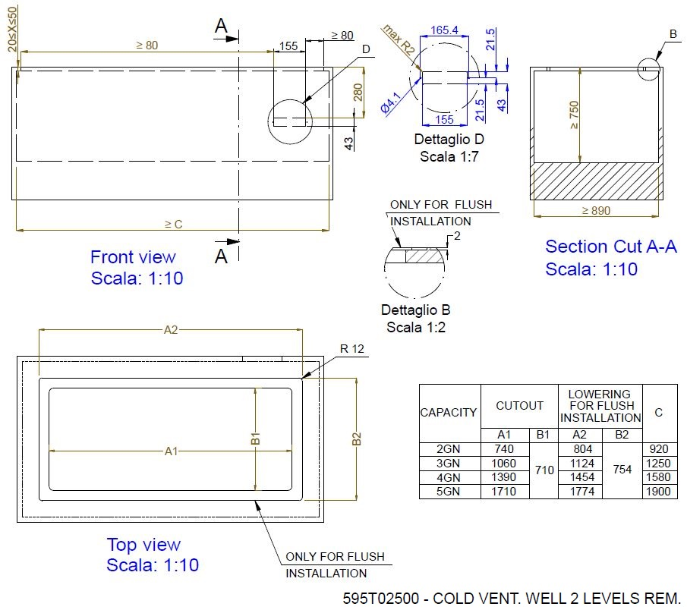
Product values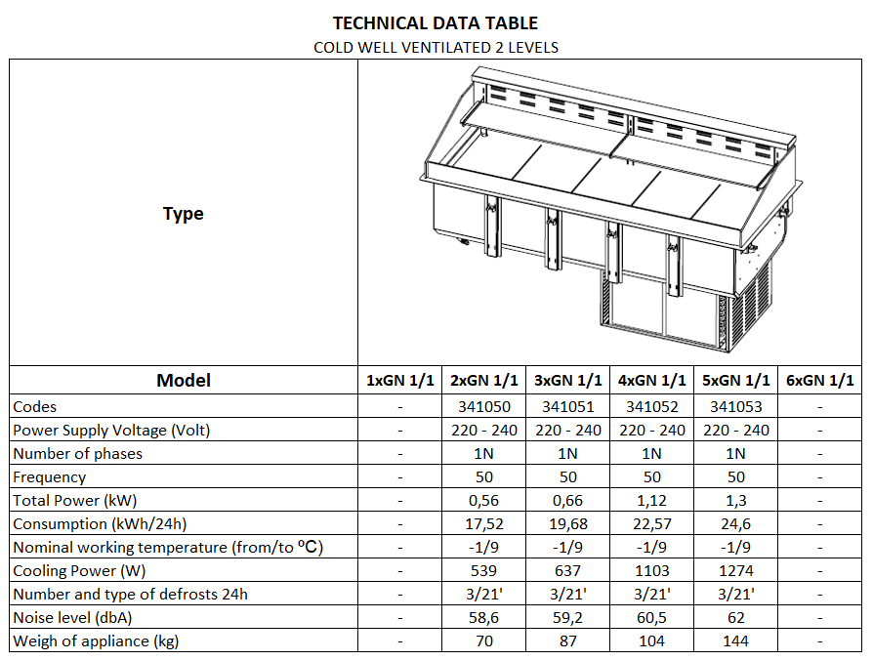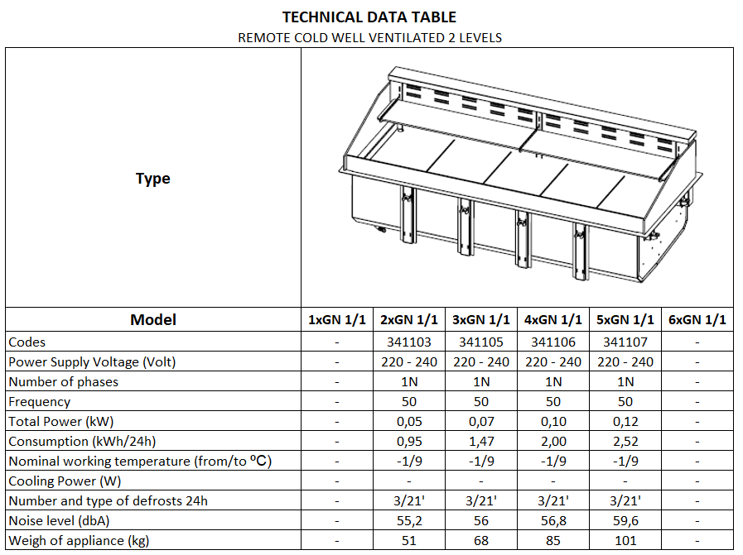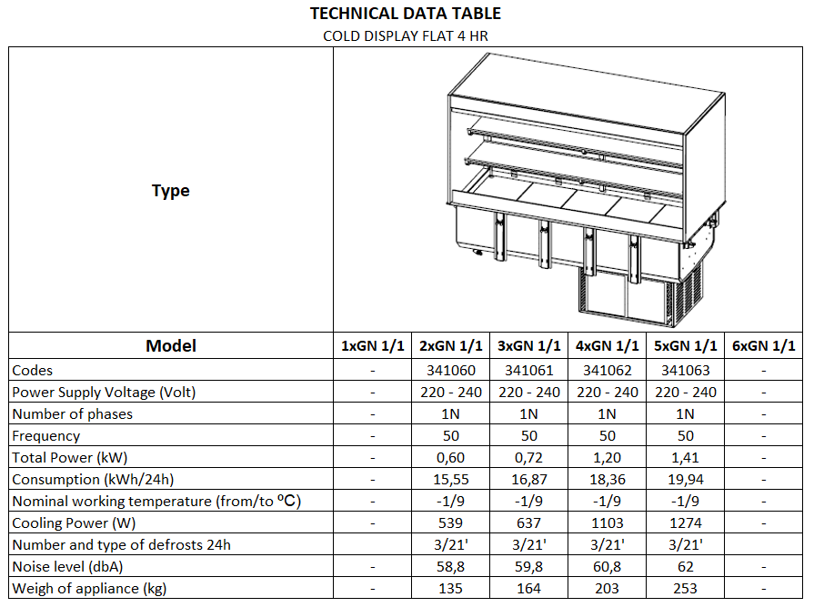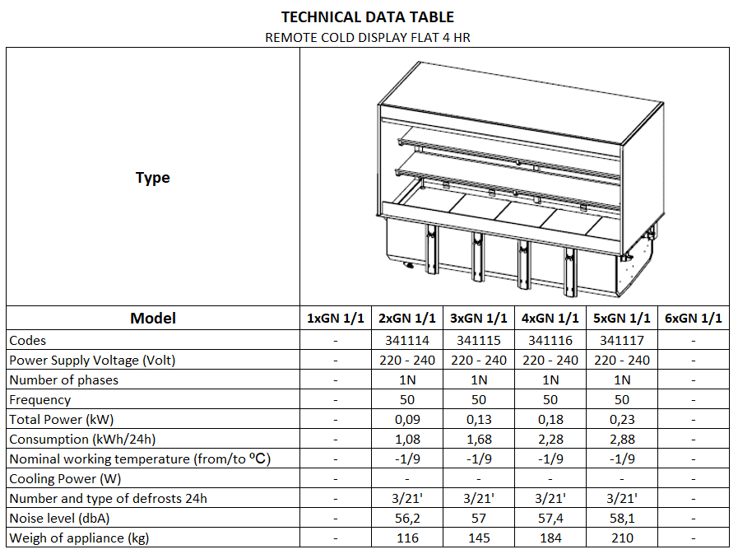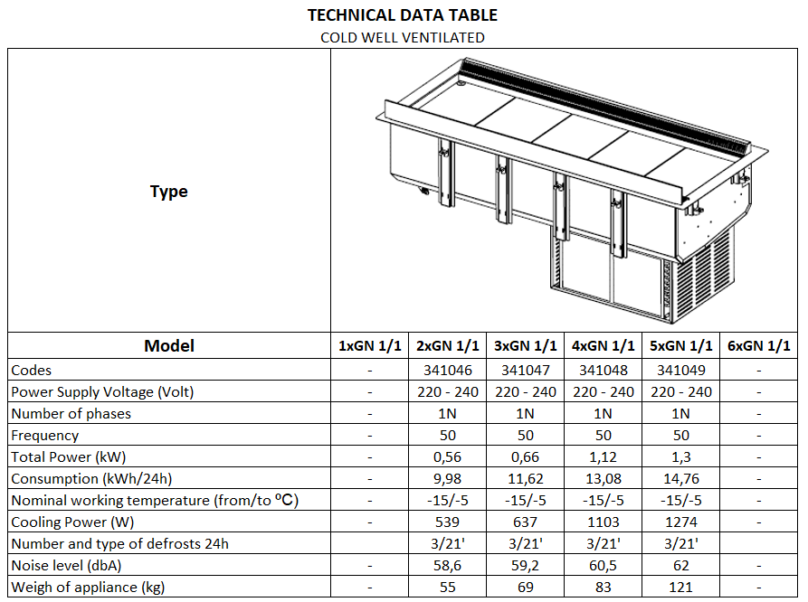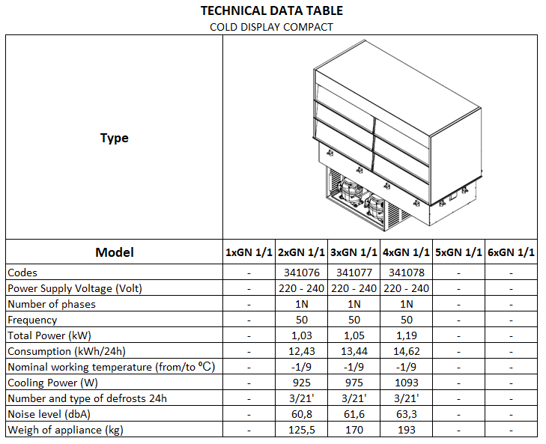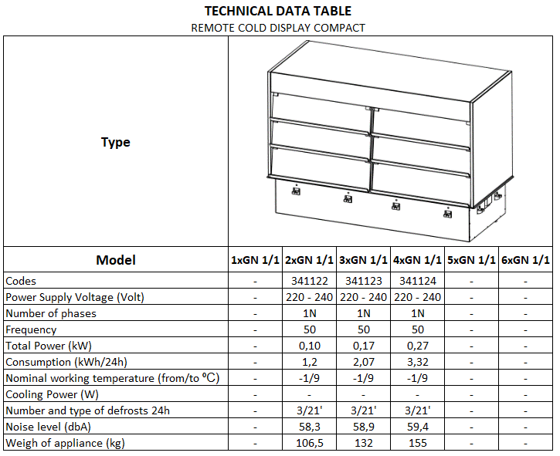

--- EN ---
Contents
Foreword 22
A.1. General information 23
A.1.1 General safety instructions 23
A.1.2 Additional indications 23
A.1.3 Introduction 23
A.1.4 Intended use and restrictions 23
A.1.5 Test and inspection 24
A.1.6 Definitions 24
A.1.7 Machine and manufacturer’s identification data 25
A.1.8 Appliance identification 26
A.1.9 Copyright 27
A.1.10 Responsibility 27
A.1.11 Personal protection equipment 27
A.1.12 Keeping the manual 28
A.1.13 Recipients of the manual 28
A.2. Technical data 28
A.2.1 Climatic class 28
A.2.2 Materials and fluids used 28
A.2.3 Dimensions, performance and consumption 28
A.2.4 Mechanical safety characteristics, hazards 28
B.1. Transport, handling and storage 29
B.1.1 Introduction 29
B.1.2 Transport: instructions for the carrier 29
B.1.3 Handling 29
B.1.4 Procedures for handling operations 29
B.1.5 Translation 30
B.1.6 Placing the load 30
B.1.7 Storage 30
B.2. Installation and assembly 30
B.2.1 Checks on receiving the appliance 30
B.2.2 Customer’s responsibility 31
B.2.3 Unpacking 31
B.2.3.1 Disposal of packing 31
B.2.4 Positioning 31
B.2.5 Fitting the appliance in the cabinet (only Drop-in range) 32
B.2.5.1 Foreword 32
B.2.5.2 Fitting and fixing the cabinet 36
B.2.6 Electrical connection 37
B.2.7 Plumbing connection 38
B.2.8 Installation of condensing unit (only for remote condensing units) 38
B.2.8.1 Positioning 39
B.2.8.2 Creating a vacuum in the pipes and filling with the refrigerant 39
B.2.9 Fitting the control panel (only drop-in products) 40
B.2.10 Fitting the main electrical box (only drop-in products) 40
D.1. How to use the control panel 41
D.1.1 Description of keys and icons 41
C.1.2 How to use the keys 41
C.1.3 Control panel symbols and screen messages 41
C.2. General safety rules 42
C.2.1 Introduction 42
C.2.2 Protection devices installed on the machine 42
C.2.2.1 Guards 42
C.2.3 Safety signs placed on the appliance or near its area 43
C.2.4 End of use 43
C.2.5 Instructions for use and maintenance 43
C.2.6 Reasonably foreseeable improper use 44
C.2.7 Residual risks 44
C.3. Normal appliance use 45
C.3.1 Characteristics of personnel trained for normal machine use 45
C.3.2 Characteristics of personnel enabled to operate on the machine 46
C.3.3 Operator for normal machine use 46
D.1. Machine cleaning and maintenance 46
D.1.1 Routine maintenance 47
D.1.1.1 Precautions for maintenance 47
D.1.1.2 Cleaning the cabinet and accessories 47
D.1.1.3 Tank cleaning 47
D.1.1.4 Precautions in case of long idle periods 48
D.1.2 Extraordinary maintenance 48
D.1.2.1 Periodical condenser cleaning 49
D.1.2.2 Replacing the power cable 49
D.1.2.3 Quick troubleshooting guide 49
D.1.3 Maintenance intervals 50
D.1.3.1 Maintenance frequency 50
D.1.4 Disassembly 51
D.1.5 Decommissioning 52
D.2. Machine disposal 52
D.2.1 Waste storage 52
D.2.2 Procedure regarding appliance dismantling macro operations 52



Foreword
 The installation, use and maintenance manual (hereinafter Manual) provides the user with information necessary for correct and safe use of the machine (hereinafter “machine” or “appliance”).
The following must not be considered a long and exacting list of warnings, but rather a set of instructions suitable for improving machine performance in every respect and, above all, preventing injury to persons and animals and damage to property due to improper operating procedures.
All persons involved in machine transport, installation, commissioning, use and maintenance, repair and disassembly must consult and carefully read this manual before carrying out the various operations, in order to avoid wrong and improper actions that could compromise the machine's integrity or endanger people. Make sure to periodically inform the user regarding the safety regulations. It is also important to instruct and update personnel authorised to operate on the machine, regarding its use and maintenance.
The manual must be available to operators and carefully kept in the place where the machine is used, so that it is always at hand for consultation in case of doubts or whenever required.
If, after reading this manual, there are still doubts regarding machine use, do not hesitate to contact the Manufacturer or the authorised Service Centre to receive prompt and precise assistance for better operation and maximum efficiency of the machine. During all stages of machine use, always respect the current regulations on safety, work hygiene and environmental protec- tion. It is the user's responsibility to make sure the machine is started and operated only in optimum conditions of safety for people, animals and property.
The manufacturer declines any liability for operations carried out on the appliance without respecting the instructions given in this manual. No part of this manual may be reproduced.

General information

General safety instructions
To ensure safe use of the machine and a proper understanding of the manual it is necessary to be familiar with the terms and typographical conventions used in the documentation.
The following symbols are used in the manual to indicate and identify the various types of hazards:
WARNING
Danger for the health and safety of operators.
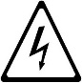
WARNING
Danger of electrocution - dangerous voltage.

WARNING
Risk of fire / flammable materials
Words further explaining the type of hazard are placed next to the symbols in the text. Warnings serve to ensure the safety of personnel.

Additional indications
In this manual the risks arising from incorrect use will be marked with:

ATTENTION
Risk of damage to the machine or the product.
The parts of the text preceded by the following symbol:

NOTE
Clarifications and explanations
provide recommendations to keep in mind during the entire life cycle of the product.
The drawings and diagrams given in the manual are not in scale. They supplement the written information with an outline, but are not intended to be a detailed representation of the machine supplied.
The numerical values given on the machine installation diagrams refer to measurements in mm.

Introduction
Given below is some information regarding the machine's in- tended use, its testing, and a description of the symbols used (that identify the type of warning), the definitions of terms used in the manual and useful information for the appliance user.

Intended use and restrictions
Our appliances are designed and optimised in order to obtain high performance and efficiency. This appliance is designed for This appliance is designed for the distribution and display of food and beverages that need to be stored at a low temperature.
The time the food is on display, must be limited to the distribution phase, as the appliances are not designed for the permanent preservation of food. The food must be contained in GN containers or crockery.
Any other use is deemed improper. The appliance must not be used by people (including children) with limited physical, sensory or mental abilities or without experience and knowledge of it, unless supervised or instructed in its use by those responsible for their safety.

ATTENTION
Do not store explosive substances, such as containers with prepellant ( 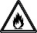 ), in this appliance.

ATTENTION
The machine is not suitable for installation out- doors and/or in places exposed to atmospheric agents (rain, direct sunlight, etc.).

Test and inspection
Our appliances are designed and optimised, with laboratory testing, in order to obtain high performance and efficiency. The product is shipped ready for use.
Passing of the tests (visual inspection - electrical test - functional test) is guaranteed and certified by the specific enclosures.

Definitions
Listed below are the definitions of the main terms used in the manual. It is advisable to read them carefully before use.
Operator
machine installation, adjustment, use, maintenance, cleaning, repair and transport personnel.
Manufacturer
Electrolux Professional SpA or any other service centre authorised by Electrolux Professional SpA.
Operator for normal machine use
an operator who has been informed and trained regarding the tasks and hazards involved in normal machine use.
After-sales service or specialised technician
an operator instructed/trained by the Manufacturer and who, based on his professional and specific training, experience and knowledge of the accident-prevention regulations, is able to appraise the operations to be carried out on the machine and recognise and prevent any risks. His professionalism covers the mechanical, electrotechnical and electronics fields.
Danger
source of possible injury or harm to health.
Hazardous situation
any situation where an operator is exposed to one or more hazards.
Risk
a combination of probabilities and risks of injury or harm to health in a hazardous situation.
Protection devices
safety measures consisting of the use of specific technical means (guards and safety devices) for protecting operators against risks.
Guard
an element of a machine used in a specific way to provide protection by means of a physical barrier.
Safety device
a device (other than a guard) that eliminates or reduces the risk; it can be used alone or in combination with a guard.
Customer
the person who purchased the machine and/or who manages and uses it (e.g. company, entrepreneur, firm).
Electrocution
an accidental discharge of electric current on a human body.

Machine and manufacturer’s identification data
A reproduction of the marking or data plate on the machine is given below:
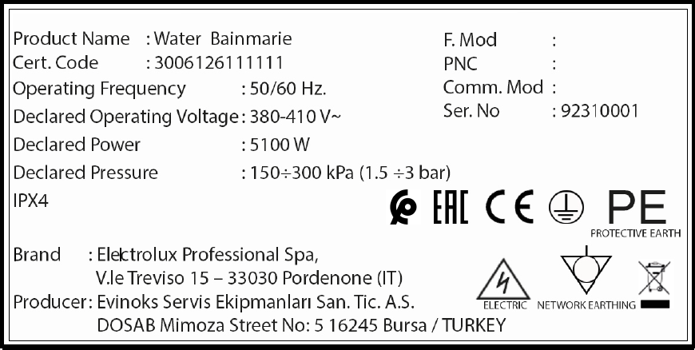
The data plate can be found:
- Drop-in products
On the electrical box
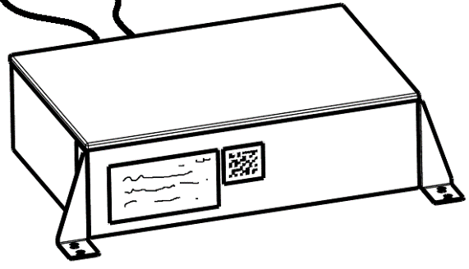
- Mobile products

In products with electrical box:
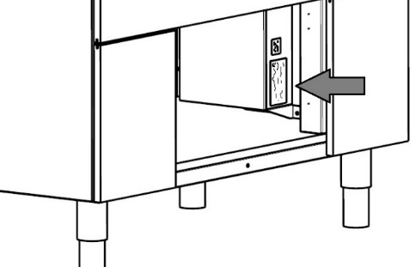
In products without electrical box:
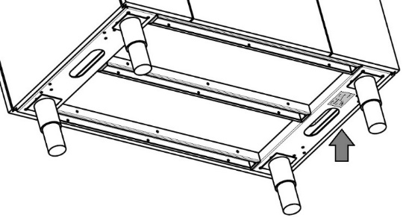

The data plate gives the product identification and technical data.
The meaning of the various information given on it is listed below:
- Product name: Function type
- F.Mod: Factory model
- Cert.code: Certification code
- PNC: Product number code
- Operating frequency: Electrical frequency suitable for this appliance
- Comm.mod: Commercial model
- Declared operating voltage: Electrical voltage suitable for this appliance
- Ser.No: Serial number of the appliance
- Declared Power: Electrical power consumption
- IPX*: Ingress protection code
When installing the appliance, make sure the electrical connection is carried out in compliance with that specified on the data plate.

ATTENTION
Do not tamper or make the machine’s marking illegible.
ATTENTION
Refer to the data given on the machine's marking for relations with the Manufacturer (e.g. when ordering spare parts, etc.).
ATTENTION
The data plate must be destroyed when scrapping the machine.

Appliance identification
This manual applies to various appliance models. For further details regarding your model, refer to par. “A.2.3 Dimensions, performance and consumption”.

Copyright
This manual is intended solely for consultation by the operator and can only be given to third parties with the permission of Electrolux Professional SpA.

Responsibility
The Manufacturer declines any liability for damage and malfunctioning caused by:
- non-compliance with the instructions contained in this manual;
- repairs not carried out in a workmanlike fashion, and re- placements with parts different from those specified in the spare parts catalogue (the fitting and use of non-original spare parts and accessories can negatively affect machine operation and invalidates the warranty);

- operations by non-specialised technicians;
- unauthorised modifications or operations;
- inadequate maintenance;
- improper machine use;
- unforeseeable extraordinary events;
- use of the machine by uninformed and untrained personnel;
- non-application of the current provisions in the country of use, concerning safety, hygiene and health in the workplace.
The Manufacturer declines any liability for damage caused by arbitrary modifications and conversions carried out by the user or the Customer.
The employer, workplace manager or service technician are responsible for identifying and choosing adequate and suit- able personal protection equipment to be worn by operators, in compliance with regulations in force in the country of use. Electrolux Professional SpA declines any liability for inaccuracies contained in the manual, if due to printing or translation errors. Any supplements to the installation, use and maintenance manual the Customer receives from the Manufacturer will form an integral part of the manual and therefore must be kept together with it.

Personal protection equipment
Phase | Protection garments   | Safety footwear   | Gloves   | Glasses   | Ear protectors   | Mask   | Safety helmet  
Transport
Handling
Unpacking
Installation
Normal use |  |  | *
Adjustments
Routine cleaning |  |  | *
Extraordinary cleaning
Maintenance
Dismantling
Scrapping

Legend: PPE required; PPE available or to be used if necessary; PPE not required
(*) During Normal use, gloves protect hands from the cold tray when being removed from the appliance.
Note: The gloves to be worn during cleaning are the type suitable for contact with the cooling fins (metal plates).
Failure to use the personal protection equipment by operators, specialised technicians or users can involve exposure to chemical risk and possible damage to health.

Keeping the manual
The manual must be carefully kept for the entire life of the machine, until scrapping.
The manual must stay with the machine in case of transfer, sale, hire, granting of use or leasing.

Recipients of the manual
This manual is intended for:
- the carrier and handling personnel;
- installation and commissioning personnel;
- the employer of machine users and the workplace manager;
- operators for normal machine use;
- specialised technicians - after-sales service (see service manual).

Technical data

Climatic class
The climatic class is written on the product data plate.

Materials and fluids used
Parts subject to use by customers are in stainless steel, aluminium, glass or non-toxic materials. An HFC refrigerant fluid complying with the current regulations is used in the refrigerating units. The type of gas used is given on the data plate.

Dimensions, performance and consumption
For the technical data relevant to the appliances refer to the data plate. For dimensions refer to the installation diagram supplied in the documentation of this product and available in the website.

Mechanical safety characteristics, hazards
The appliance does not have sharp edges or protruding parts.
The guards for the moving and live parts are fixed to the cabinet with screws, to prevent accidental access.

Transport, handling and storage

Introduction
Transport (i.e. transfer of the machine from one place to another) and handling (i.e. transfer inside workplaces) must occur with the use of special and adequate means.
ATTENTION
Due to their size, machines cannot be on top of each other during transport, handling and storage; this eliminates any risk of loads tipping over due to staking.
NOTE: The machine must only be transported, handled and stored by qualified personnel, who must:
- have specific technical training and experience in the use of lifting systems;
- have knowledge of the safety regulations and applicable laws in the relevant sector;
- have knowledge of the general safety rules;
- ensure the use of personal protection equipment suitable for the type of operation carried out;
- be able to recognise and avoid any possible hazard.

Transport: instructions for the carrier
ATTENTION
Do not stand under suspended loads during loading/unloading operations. Unauthorised personnel must not enter the work area.
ATTENTION
The machine’s weight alone is not sufficient to keep it steady. The transported load can shift:
- When braking;
- When accelerating;
- In corners;
- On rough roads

Handling
Arrange a suitable area with flat floor for machine unloading and storage operations.
ATTENTION
The appliance must be handled in the upright position. If the appliance is handled in a horizontal position, make sure to wait a few hours before making it operational

Procedures for handling operations
For correct and safe lifting operations:
- use the type of equipment most suitable for characteristics and capacity (e.g. electric pallet truck or lift truck);
- cover sharp edges;
Before lifting:
- send all operators to a safe position and prevent persons from entering the handling area;
- make sure the load is stable;
- make sure no material can fall during lifting. Manoeuvre vertically in order to avoid impacts;
- handle the machine, keeping it at minimum height from the ground.
ATTENTION
For machine lifting, do not use movable or weak parts such as: casings, electrical raceways, preumatic parts, etc.

Translation
The operator must:
- have a general view of the path to be followed;
- stop the manoeuvre in case of hazardous situations.
ATTENTION
Do not push or pull the appliance to move it, as it may tip over.

Placing the load
Before placing the load, make sure the way is free and that the floor is flat and can take the load.

Storage
The machine and/or its parts must be stored and protected against damp, in a non-aggressive place free of vibrations and with room temperature between -10°C and 50°C.
The place where the machine is stored must have a flat support surface in order to avoid any twisting of the machine or damage to the support feet.
ATTENTION
Appliance positioning, installation and disassembly must be carried out by a specialized technician.
ATTENTION
Do not make modifications to the parts supplied with the appliance. Any missing or faulty parts must be replaced with original parts.

Installation and assembly
To ensure correct appliance operation and maintain safe conditions during use, carefully follow the instructions given below in this section.

Checks on receiving the appliance
The appliance is delivered in protective packing. Check the state of the packing and any protective materials before unpacking. Any damage must be reported immediately to the carrier. Under no circumstances should a damaged appliance be returned to the manufacturer without prior notice and written authorisation.
ATTENTION
The operations described below must be carried out in compliance with current safety regulations, regarding the equipment used and the operating procedures.
ATTENTION
Before moving the appliance, make sure the capacity of the lifting equipment used is suitable for its weight.

Customer’s responsibility
The customer must:
- Arrange the connection to a drain system for the condensation water.
- Check the flatness of the surface on which the machine is placed.

Unpacking
Use a fork-lift truck or pallet truck to handle the equipment, inserting the forks under the pallet, and carry it to the place of installation, making sure that the load is balanced.
Remove the protective film and polystyrene padding, taking care not to scratch the sheet metal with any scissors or blades used.
Cut the straps securing the glass to the cabinet and remove the corners.
Undo the 4 top corner screws fixing the equipment to the pallet and cut the straps.
Lift the product from bottom and/or structural parts. Important: do not lift it from the sheet metal frame in order to avoid bending/deformation.

Disposal of packing
The packing must be disposed of in compliance with the current regulations in the country where the appliance is used. All the packing materials are environmentally friendly. They can be safely kept, recycled or burned in an appropriate waste incineration plant. Recyclable plastic parts are marked as follows:
 | Polyethylene | Outer wrapping; instruction booklet bag, pluriball
 | Polypropylene | Straps
 | Polystyrene foam | Corner protectors

The parts in wood and cardboard can be disposed of, respecting the current regulations in the country where the machine is used.

Positioning
ATTENTION
Do not push or pull the appliance to move it, as it may tip over.
Install the appliance, taking all the safety precautions required for this type of operation, also respecting the relevant fire prevention instructions. Install the appliance in a ventilated place, away from heat sources such as radiators or air conditioning systems, to allow correct cooling of the refrigerating unit components.
If the appliance is installed in a place where there are corrosive substances (chlorine, etc.), it is advisable to go over all the s/steel surfaces with a cloth moistened with paraffin oil to create a protective film.
Only for Drop-in products: the appliance is designed for fitting in a previously prepared cabinet (refer to the indications given on the installation design suggestions attached to this manual).
Appliance performance characteristics are guaranteed at an ambient temperature of +25°C. The max. ambient temperature at which the machines can operate is +32°C.
Don’t install this appliance in rooms where the ambient temperature drops below +5°C.
Before installing the appliance check the flatness of the cabinet in which it is to be fitted.
The appliance must be installed in a room with floor area greater than the value written in the below table.

Code | Minimum area  m²
341046 | 7,7
341047 | 10,05
341048 | 14,4
341049 | 14,4
341050 | 7,2
341051 | 7,2
341052 | 14,4
341053 | 7,2
341060 | 7,7
341061 | 10,55
341062 | 15,35
341063 | 14,4
341076 | 8,65
341077 | 12,95
341078 | 14,85
322036 | 8,65
322037 | 12,95
322038 | 14,85

ATTENTION
Wear safety gloves when carrying out equipment assembly operations.

Fitting the appliance in the cabinet (only Drop-in range)

Foreword
ATTENTION
Never install the appliance inside cabinets in wood treated with paints, primers or other flammable materials!
For the appliance to operate correctly the cabinet in which it is fitted must be suitable to house it.
First of all, take into account the weight of the equipment to be placed inside the structure, therefore provide for a cabinet that can take its weight.
For furniture minimum dimensions see the specific sheet included in the documentation of this product.
The product has “remote” controller and electrical box. Please refer both to “Installation design suggestion” and “Installation drawing” to detect their possible installation position.
Important:
The furniture must assure access to components for maintenance.
Two types of installation are possible:
- Equipment raised with respect to the top
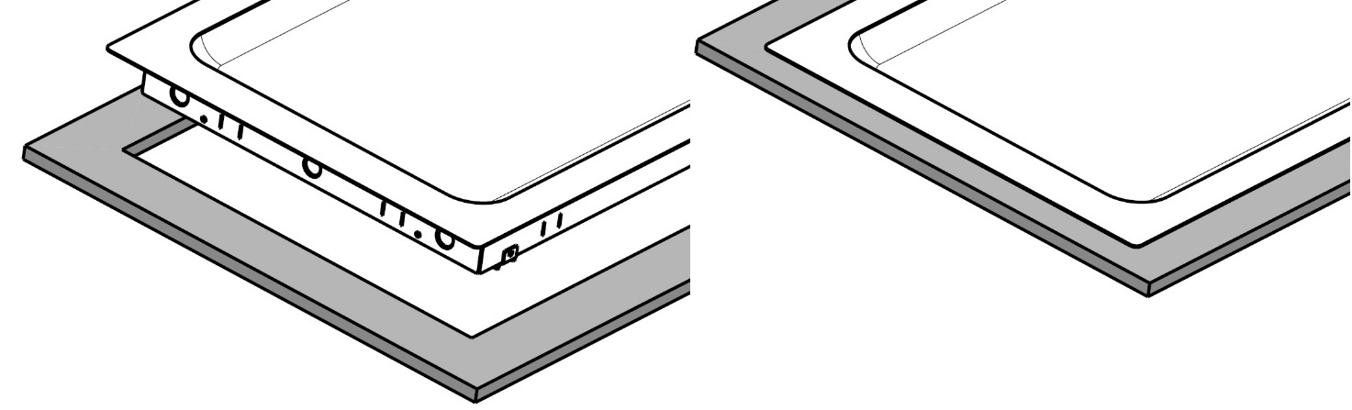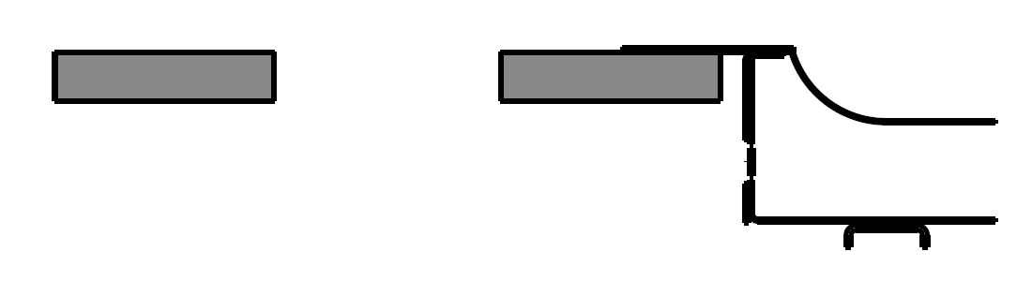
- Equipment flush with the top
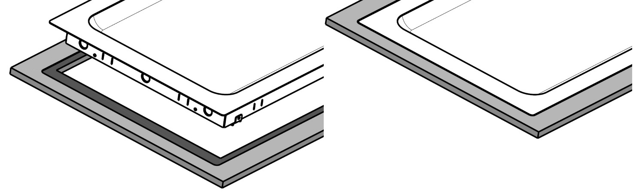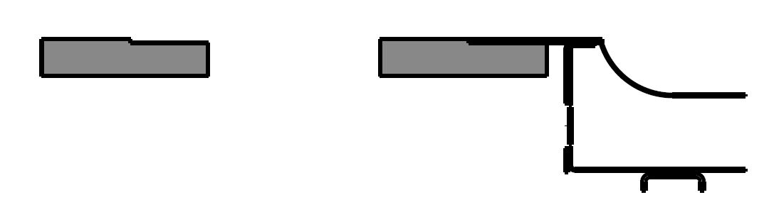
silicone
Also, a hole must be made for air intake and another for air exhaust. Three explanatory diagrams are given below:
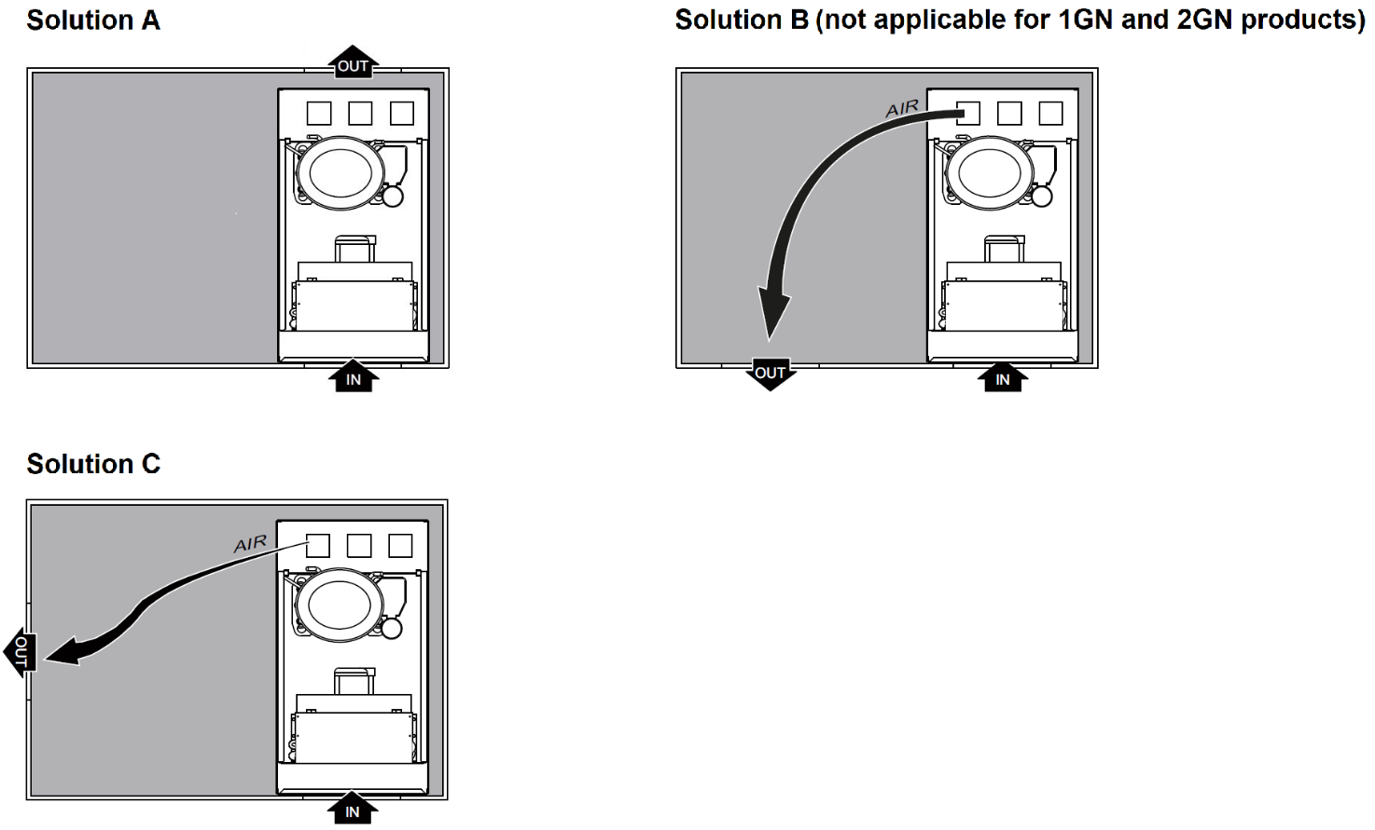
Solution “A” is advisable in case of island installations.
The previously prepared holes must be closed with protection grills (not supplied) which allow the air to freely circulate.
Important:
The grilles must have a passage area of not less than 0.06 m² and hole size of not more than 8.5mm, to protect fingers
2 configurations are possible, according to the cabinet in which the appliance is fitted:
- short distance between condensing unit and cabinet:
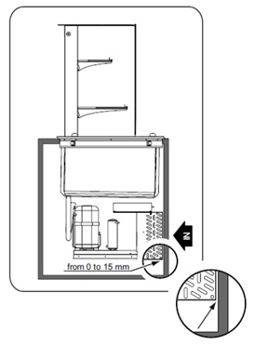
- ample distance between condensing unit and cabinet:
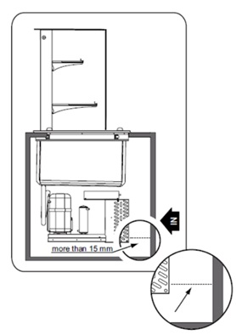
In the latter configuration, side closures (not supplied) must be provided for, as shown in the image below:
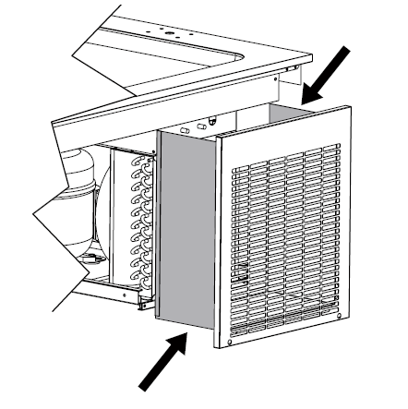

It is advisable to provide for side closures also with type “1” configuration, as indicated for type “2” configuration.
On the customer side there are no minimum distances between the cabinet and the appliance.

Fitting and fixing the cabinet
It is possible to use the provided fixing tabs to lift the product with a pipe (not provided) as shown below.
Make sure lifting pipe is strong enough for the weight of the appliance.

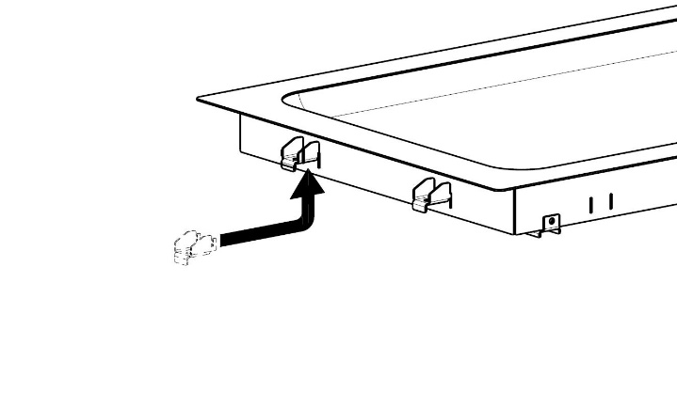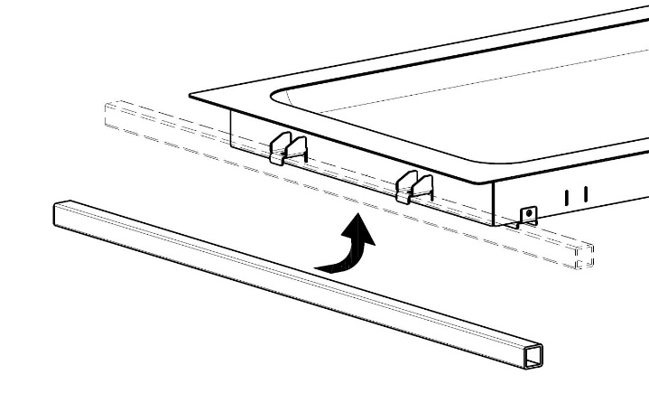
If you used the above described lifting method, make sure to remove the tabs before to insert the function in the furniture.

- Once the product is inserted in the furniture, insert the provided fixing tabs (rotated 180° compared to the previous position) in the dedicated cuts, then tighten the screws.
ATTENTION
Do not overtighten the screws since this may damage the top and/or create ondulations on the visible surfaces.
Be sure the tabs are rotated as shown in the picture below.
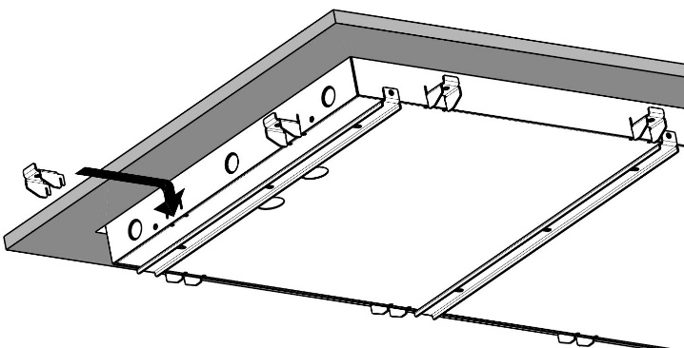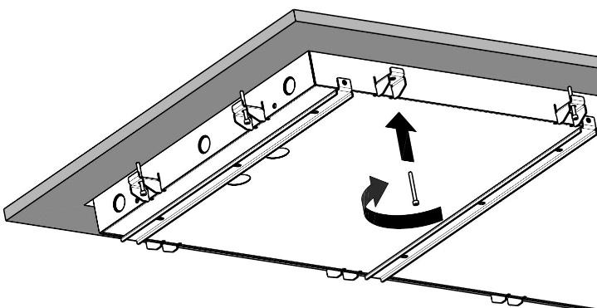

Electrical connection
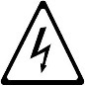
ATTENTION
If the power cable is damaged it must be replaced by After-Sales Service or in any case by qualified personnel, in order prevent any risk.
The manufacturer declines any liability for damage or injury resulting from breach of the above rules or non-compliance with the electrical safety regulations in force in the country where the machine is used.
Connection to the power supply must be carried out in compliance with the regulations and provisions in force in the country of use.
ATTENTION
Work on the electrical systems must only be carried out by a qualified electrician.
When making the electrical connection, carefully comply with that given on the data plate.
Electrical safety can only be guaranteed if the product is connected to an efficient earth system, in compliance with current electrical safety standards.
The installer is responsible for correct electrical connection according to local regulations.
For connection, first make sure:
- the connection point has an efficient earth contact and the mains voltage and frequency match that given on the data plate. In case of doubts regarding the efficiency of the earth wire, have the system checked by qualified personnel;
- the system power supply is arranged and able to take the actual current absorption and that it is correctly executed according to the regulations in force in the country of use;
- the appliance must be permanently connected to the power supply, respecting the polarities:
  - brown: phase
  - green/yellow: earth
  - blue: neutral;
- a differential thermal-magnetic switch suitable for the absorption specified on the data plate, with contact gap enabling complete disconnection in category III overvoltage conditions and complying with the regulations in force, is installed between the power cable and the electric line. For the correct size of the switch, refer to the absorbed current specified on the appliance data plate.
The device used must be lockable in the open position in case of maintenance.
After making the connection, with the machine working check that the power supply does not fluctuate by ±10% the rated voltage.
ATTENTION
Do not switch the appliance on before the electrical wiring cover panels have been fitted.

Plumbing connection
ATTENTION
The plumbing connection must be carried out by a specialised technician.
It is possible but not mandatory to connect mobile products to water drain system: the water can be drained into a recipient (not provided).
Please refer to the Installation Diagram included in the documentation of this product to know drain size and position.
Emptying must occur through a trap into an open drain, to prevent any backflow from the drainage system reaching the internal pipes.
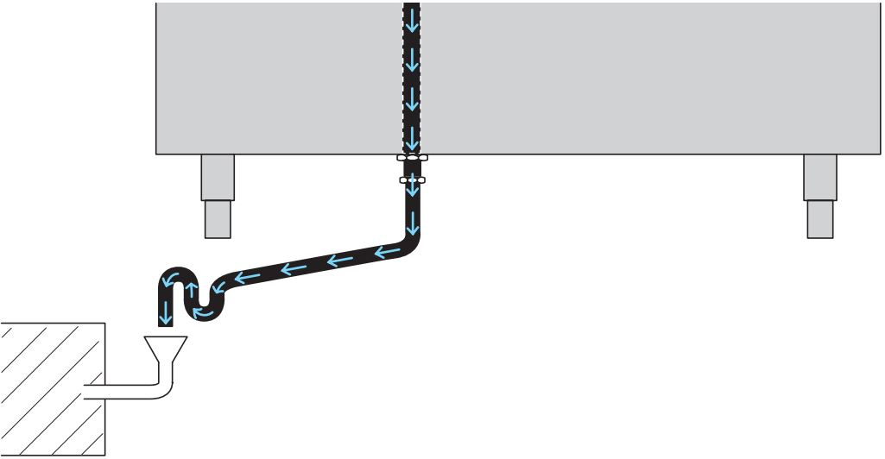

Installation of condensing unit (only for remote condensing units)
ATTENTION
Installation of the appliance and the refrigerant fluid condensing unit must only be carried out by the manufacturer’s service personnel or by a qualified person.
ATTENTION
Wear suitable protection equipment (protective gloves) when carrying out installation operation.

Positioning
Install the appliance, taking all the safety precautions required for this type of operation. Place the condenser unit in a well-ventilated room away from heat sources.
If the remote unit is installed outdoors, it must be protected against atmospheric agents with a suitable cover, in any case guaranteeing proper ventilation of the condensing unit.
Choose pipe sizes according to that given in the technical data (for recommended units). Lay the copper piping, choosing the shortest path and avoiding bends, elbows and vertical sections as much as possible, keeping to the following:
- In horizontal sections, the intake line must have a downslope towards the condensing unit of at least 2%. - Traps must be installed (every 2 m) before all upward sections of the intake line;
- Insulate the intake line with suitable lagging (min. thickness 9 mm)
- It is advisable to install the remote unit, providing for pipes not exceeding 15 m in length, with a maximum height difference of 5 m between the unit and appliance.
- Install on the delivery line, in order to indicated: a suitable dehydration filter and a liquid flow indicator (1 solenoid valve is already installed in the static appliances)

Creating a vacuum in the pipes and filling with the refrigerant
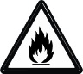
ATTENTION
The refrigerant gas is R290
Leakage test
- Clean the suction and delivery pipes with dry nitrogen under pressure.
- Connect a nitrogen cylinder to the high and low pressure pipe taps, taking care to install a pressure gauge (using a union-tee). Inject the gas into both the high and the low pressure line until a pressure of approx. 15 bar has been reached. Close the cylinder tap and after a minimum of one hour check that the pressure has not dropped below the previously measured value.
Vacuum
- Empty the circuit manually by opening the cocks of the connections with inlet solenoid powered.
- Connect the pipes to a vacuum pomp, preferably a two-stage model with a vacuum gauge and high and low pressure connectors. Reach a vacuum level equal to or lower than 70m Torr (0.0931 mbar). On reaching this level, maintain it for about 30 minutes at least, charge the unit as follows.
Charging with refrigerant
- Charge the high and low pressure lines with liquid refrigerant until the pressure between the cylinders and the circuit is balanced (the initial charge of fluid is about 20 to 30% of the total charge)
- Then, shut off the high pressure line, start the compressor and charge with gas slowly until the bubbles in the liquid indicator disappear
ATTENTION
The refrigerant should be loaded by professionally qualified personnel.
Checks to be made when starting the appliance
Check on the refrigerant liquid flow indicator that the circuit is sufficiently charged. Otherwise, complete the charging following the instructions in the previous paragraph.
Using a digital thermometer, check that the temperature reading on the control panel matches the instrument reading.
In condensing units, it is advisable to check the correct return of oil to the compressor
The manufacturer cannot be held liable should these accident-prevention rules and regulations not be observed.

Fitting the control panel (only drop-in products)
ATTENTION
Before to proceed, make sure the appliance is not connected to the electrical supply line!
- Remove the plastic front cover (if already installed on the controller)
- Undo the screws
- Remove the protections for the connectors
- Pass the connectors through the hole arranged in the furniture and join the components
- After fitting the connectors to their places, install the control to the panel with the screws supplied
- Install the plastic front cover pushing it in position
For possible position of controller refer to the Installation design suggestion included in the documentation of this product.

Fitting the main electrical box (only drop-in products)
The main electrical box of this appliance can be installed in the most convenient position according to the design of the furniture. An easy access to the electrical box must be provided to allow the service during product lifecycle.
For possible position of electrical box refer to the Installation design suggestion included in the documentation of this product.
IMPORTANT: the electrical box must be installed inside the furniture within 1,5m from the center of the function. Also consider that the cable from electrical box to thermoregulator is 1,5 meters long.

How to use the control panel

Description of keys and icons
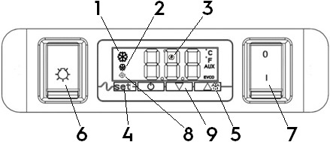
- Compressor working icon
- Defrost icon
- Low energy consumption icon
- Setting key
- Manual defrost key (press and hold for 4 seconds) / Up key
- Lights on/off switch
- Function on/off switch
- Evaporator fan icon
- Down key

How to use the keys
To unlock the keyboard («Loc» text on the screen):
Press any button for more than 2 seconds until «UnL» will appear on the screen. You can use the keys.
Note: For security reasons, if the keys are not pressed within 30 seconds, the display will show the message “Loc” for 1 s and the keyboard will lock automatically.
To set the working temperature:
- Touch the  Key: set value appears on the screen and the indicator  will flash.
- Touch the  or  Key within 20s to change the value.
- Touch the key or do not operate for 20 s. The new set is now stored

Control panel symbols and screen messages
The meaning of each icon is described in the below table.
In case of alarms displayed on the screen, please refer to Troubleshooting chapter.
LEDs/Icons | DESCRIPTIONS
 | Compressor LED  - When the LED is lit continuously the compressor is working  - When the LED is blinking  - Setpoint editing  - Compressor protection phase
 | Defrost LED  - When the LED is lit continuously, the defrost phase is in progress  - When the LED is blinking  - Defrost is needed but the a compressor protection phase is in progress  - Dripping is in progress
 | Evaporator fan LED  - When the LED is lit continuously, the fan(s) for the evaporator is on  - When the LED is blinking a protection is in progress
 | Energy saving LED  - When the LED is lit continuously, energy saving function is activated  - When the display is off, the controller is in “low consumption mode”. Press any key to restore the display
 | LED Celsius degree  When lit the temperature shown is in Celsius degrees
 | LED Fahrenheit degree  When lit the temperature shown is in Fahrenheit degrees
 | On/stand-by LED  When lit the appliance is off

General safety rules

Introduction
The machines are provided with electric and/or mechanical safety devices for protecting workers and the machine itself, therefore the user must not remove or tamper with such devices.
The Manufacturer declines any liability for damage due to tampering or their non-use.

Protection devices installed on the machine

Guards
The guards on the machine are:
- fixed guards (e.g. casings, covers, side panels, etc.), fixed to the machine and/or frame with screws or quick-release connectors that can only be removed or opened with tools;
- interlocked movable guards (door) for access inside the machine;
- machine electrical equipment access doors, made with hinged panels openable with tools. The door must not be opened when the machine is connected to the power supply.

ATTENTION
Several illustrations in the manual show the machine, or parts of it, without guards or with guards removed. This is purely for explanatory purposes. Do not use the machine without the guards or with the protection devices deactivated.

Safety signs placed on the appliance or near its area
Prohibition | Meaning
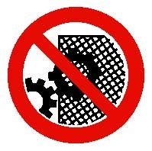 | do not remove the safety devices
 | do not use water to extinguish fires (placed on electrical parts)
Danger | Meaning
 | caution hot surface
 | danger of electrocution (shown on electrical parts with indication of voltage)

ATTENTION
Do not remove, tamper with or make illegible the safety, danger and instruction signs and labels on the machine.

End of use
When the appliance is no longer to be used, make it unusable by removing the mains power supply wiring.

Instructions for use and maintenance
- Risks mainly of a mechanical, thermal and electrical nature exist in the machine. Where possible the risks have been neutralized:
  - directly, by means of adequate design solutions.
  - indirectly by using guards, protection and safety devices.
- Any anomalous situations are signaled on the control panel display.
- During maintenance several risks remain, as these could not be eliminated, and must be neutralized by adopting specific measures and precautions.
- Do not carry out any checking, cleaning, repair or maintenance operations on moving parts. Workers must be informed of this prohibition by means of clearly visible signs.
- To guarantee machine efficiency and correct operation, periodical maintenance must be carried out according to the instructions given in this manual.
- Make sure to periodically check correct operation of all the safety devices and the insulation of electrical cables, which must be replaced if damaged.
- Repair and extraordinary Maintenance have to be carried out by specialized authorized personnel provided with all the appropriate personal protection equipment, tools, utensils and ancillary means.
- Never operate the machine, removing, modifying or tampering with the guards, protection or safety devices.
ATTENTION
Extraordinary machine maintenance operations must only be carried by specialized technicians provided with all the appropriate personal protection equipment (safety shoes, gloves, glasses, overalls, etc.), tools, utensils and ancillary means.
Never operate the machine removing, modifying or tampering with the guards, protection or safety devices.
Before carrying out any operation on the appliance always consult the manual, which gives the correct procedures and contains important information on safety.

Reasonably foreseeable improper use
Improper use is any use different from that specified in this manual. During machine operation, other types of work or activities deemed improper and that in general can involve risks for the safety of operators and damage to the appliance are not allowed. Reasonably foreseeable improper use includes:
- lack of machine maintenance, cleaning and periodical checks;
- structural changes or modifications to the operating logic;
- tampering with the guards or safety devices;
- failure to use personal protection equipment by operators, specialized personnel and maintenance personnel;
- failure to use suitable accessories (e.g. use of unsuitable equipment or ladders);
- keeping combustible or flammable materials, or in any case materials not compatible with or pertinent to the work, near the machine;
- wrong machine installation;
- placing in the machine any objects or things not compatible with its use, or that can damage the machine, cause injury or pollute the environment;
- climbing on the machine;
- non-compliance with the requirements for correct machine use;
- other actions that give rise to risks not eliminable by the Manufacturer.

ATTENTION
The previously described actions are prohibited!

Residual risks
The machine has several risks that were not completely eliminated from a design standpoint or with the installation of adequate protection devices. Nevertheless, through this manual the Manufacturer has taken steps to inform operators of such risks, carefully indicating the personal protection equipment to be used by them. Sufficient spaces are provided for during the machine installation stages in order to limit these risks.
To preserve these conditions, the areas around the machine must always be:
- kept free of obstacles (e.g. ladders, tools, containers, boxes, etc.);
- clean and dry;
- well lit.
For the Customer's complete information, the residual risks remaining on the machine are indicated below: such actions are deemed improper and therefore strictly forbidden.
Residual risk | Description of hazardous situation
Slipping or falling | The operator can slip due to water or dirt on the  floor
Burns/abrasions (e.g. heating elements, cold pan, cooling circuit plates and pipes) | The operator deliberately or unintentionally touches some components inside the machine without using protective gloves
Electrocution | Contact with live parts during maintenance operations carried out with the electrical panel powered
Falling from above | The operator intervenes on the machine using unsuitable systems to access the upper part (e.g. rung ladders, or climbs on it)
Crushing or injury | The specialized personnel may not correctly fix the control panel when accessing the technical compartment. The panel could close suddenly.
Tipping of loads | When handling the machine or the packing containing it, using unsuitable lifting systems or accessories or with the unbalanced load
Chemical (refrigerant gas) | Inhalation of refrigerant gas. Therefore always refer to the appliance labels

Normal appliance use
At room temperature of 25°C, consider the below pull down period before serving;
- 15 minutes for Cold Stainless Steel Surface,
- 85 minutes for Cold Quartz Surface,
- 85 minutes for Cold Well Static with Fan,
- 110 minutes for Cold Well Static.
The food preservation to be in compliance with HACCP norms.
Remove the food at the end of distribution phase and clean the appliance.
IMPORTANT: The appliances are not suitable for installation outdoors and/or in places exposed to atmospheric agents (rain, direct sunlight, etc.).
These appliances are intended to be used for commercial applications, for example in kitchens of restaurants, canteens, hospitals and in commercial enterprises such as bakeries, butcheries, etc., but not for continuous mass production of food
The Manufacturer declines any liability for improper use of the products.

Characteristics of personnel trained for normal machine use
The Customer must make sure the personnel for normal machine use are adequately trained and skilled in their duties, as well as ensuring their own safety and that of other persons.
The Customer must make sure his personnel have understood the instructions received and in particular those regarding work hygiene and safety in use of the machine.

Characteristics of personnel enabled to operate on the machine
The Customer is responsible for ensuring that persons assigned to the various duties:
- read and understand the manual;
- receive adequate training and instruction for their duties in order to perform them safely;
- receive specific training for correct machine use.

Operator for normal machine use
He must have at least:
- knowledge of the technology and specific experience in operating the machine;
- adequate general basic education and technical knowledge for reading and understanding the contents of the manual;
- including correct interpretation of the drawings, signs and pictograms;
- sufficient technical knowledge for safely performing his duties as specified in the manual;
- knowledge of the regulations on work hygiene and safety.
In case of a significant anomaly (e.g. short circuits, wires coming out of the terminal block, motor breakdowns, worn electrical cable sheathing, etc.) the operator for normal machine use must:
- immediately deactivate the machine.

Machine cleaning and maintenance
ATTENTION
Before carrying out any cleaning or maintenance operation, disconnect the appliance from the power supply, making sure the device provided is locked in the open position
ATTENTION
During maintenance, the cable and plug must be kept in a visible position by the operator carrying out the work.
ATTENTION
Do not touch the appliance with wet hands or feet or when barefoot.
Do not remove the safety guards.
ATTENTION
Use suitable personal protection equipment (protective gloves)
ATTENTION
Use a ladder with suitable protection for work on appliances with high accessibility.
ATTENTION
Disconnect the power supply before cleaning the appliance.

Routine maintenance

Precautions for maintenance
Routine maintenance operations can be carried out by non-specialised personnel, carefully following the instructions given below. The manufacturer declines any liability for operations carried out on the appliance without following these instructions.

Cleaning the cabinet and accessories
Before using the appliance, clean all the internal parts and accessories with lukewarm water and neutral soap or products that are over 90% biodegradable (in order to reduce the emission of pollutants into the environment), then rinse and dry thoroughly. Do not use solvent-based detergents (e.g. trichloro-ethylene) or abrasive powders for cleaning. It is advisable to go over the stainless steel surfaces with a cloth moistened with paraffin oil to create a protective film.
Check the power cable regularly and replace it in case of signs of wear.
Have the appliance checked periodically (at least once a year).
ATTENTION
Do not clean the appliance with jets of water.

ATTENTION
Do not use steel wool or similar material to clean stainless steel surfaces. Do not use detergents containing chlorine, solvent-based detergents (e.g. trichloro-ethylene) or abrasive powders.
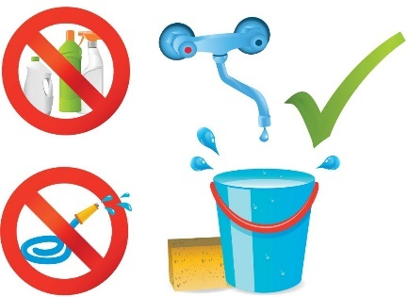

Tank cleaning
Clean the tank using lukewarm water and neutral soap or products that are over 90% biodegradable (in order to reduce the emission of pollutants into the environment), then rinse and dry thoroughly. Do not use solvent-based detergents (e.g. trichloroethylene) or abrasive powders. Use vinegar to remove any scale in the tank.
Only for ventilated wells: this equipment is designed to allow thorough cleaning of the tank, thanks to the possibility of unhooking the shelves and sheet panels inside it. You can see below how the covering panels and shelves can be removed.
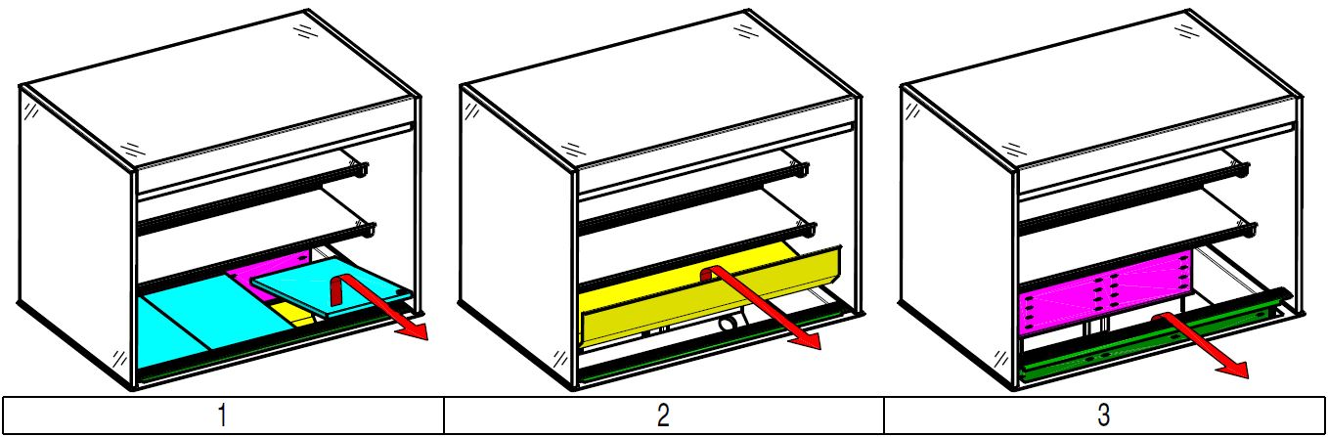
ATTENTION
After cleaning the tank, make sure to correctly refit the sheet panels.

Precautions in case of long idle periods
If the appliance is not going to be used for some time, take the following precautions:
- disconnect the power supply;
- remove all food and clean the equipment;
- air the room periodically.
ATTENTION
Machine maintenance, checking and overhaul operations must only be carried out by a specialised Technician or the After-Sales Service, provided with adequate personal protection equipment (safety shoes and gloves), tools and ancillary means.
ATTENTION
Work on the electrical equipment must only be carried out by a specialised electrician or the After-Sales Service
ATTENTION
Put the machine in safe conditions before starting any maintenance operation.
After carrying out maintenance make sure the machine is able to work safely and, in particular, that the protection and safety devices are efficient.
ATTENTION
Respect the requirements for the various routine and extraordinary maintenance operations. Non-compliance with the instructions can create risks for personnel.

Extraordinary maintenance
ATTENTION
Wear protective gloves and a mask when carrying out any extraordinary maintenance operations.
Extraordinary maintenance must be carried out by specialised personnel, who can ask the manufacturer to supply a servicing manual.

Periodical condenser cleaning
Periodical cleaning of the equipment depends on the frequency of its use.
Pay attention to the electrical cables!

To ensure optimum appliance operation clean the refrigerating unit condenser at least once every three months.
Note: It is advisable to use a brush or vacuum cleaner to remove the dirt accumulated on the condenser. Do not use sharp objects, which could damage the condenser
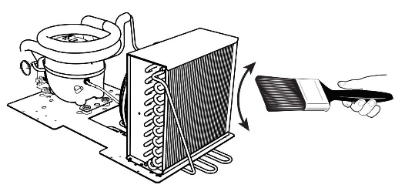
The condenser can be reached:
- In drop-in products according to furniture design
- In mobile products from the front side; the condenser is behind the front panel, on right side.
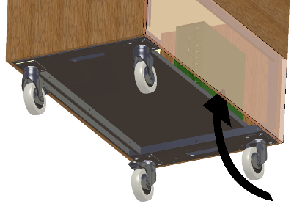

Replacing the power cable
To replace the power cable proceed as follows:
- disconnect the power;
- remove the electrical box;
- replace the power cable;
- refit the electrical box;
- switch the power on.
ATTENTION
The cable used for permanent connection to the mains power supply is of the type H07RN-F; when replacing, use a cable having at least these characteristics.
NOTE: When replacing the cable, the earth wire must be kept longer than the live and neutral wires.

Quick troubleshooting guide
In some cases, faults can be eliminated easily and quickly by following a brief troubleshooting guide:
- The appliance does not switch on:
  - check the correct power supply at the point of connection to the permanent system.
  - make sure the socket is powered.
- The inside temperature is too high:
  - check the temperature setting.
  - make sure there is no heat source near the appliance.
  - make sure the condenser is clean.
- The appliance is too noisy:
  - make sure the fan and condenser work (bringing a piece of paper near the elements)
If the fault persists after carrying out the above checks, contact the After-Sales Service, remembering to give the following details:
- the type of fault;
- the appliance PNC (production code);
- the Ser. No. (appliance serial number).
Note: The code and serial number are essential for identifying the type of appliance and date of manufacture:
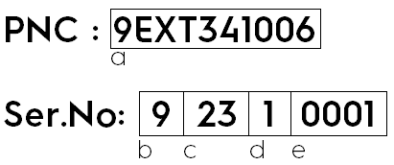
- Appliance identification code
- Fourth week of the year of production
- Week of production
- Third week of the year of production
- Quantity of products with this PNC produced in this week
The above example means that it is the first product produced in week 23 of year 2019.

Maintenance intervals
The inspection and maintenance intervals depend on the actual machine operation conditions and ambient conditions (presence of dust, damp, etc.), therefore precise time intervals cannot be given. In any case, careful and periodical machine maintenance is advisable in order to minimise interruptions of the service.
It is advisable to stipulate a scheduled preventive maintenance contract with the After-Sales Service.

Maintenance frequency
Maintenance, checks, inspections and cleaning | Frequency
Routine cleaning  General cleaning of machine and surrounding area | Daily
Mechanical protection devices  Check condition, and for any deformation, loosening or removed parts | Monthly
Control  Check mechanical part, for any breakage or deformation, tightening of screws. Check Readability and condition of words, stickers and symbols, and restore if necessary | Yearly
Machine structure  Tightening of main bolts (screws, fixing systems, etc.) of machine | Yearly
Safety signs  Check readability and condition of safety signs | Yearly
Electrical control panel  Check the electrical components installed inside the Electric Control Panel. Check wiring between the Electrical Panel and machine parts. | Yearly
Electrical connection cable  Check connection cable (replace it if necessary) | Yearly
General machine overhaul  Check all components, electrical equipment, corrosion, pipes… | Every 10 years (*)

(*) The machine is designed and built for a duration of about 10 years. After this period of time (from machine commissioning) the machine must undergo a general inspection and overhaul. Some examples of checks to be carried out are given below.
- check for any oxidised electrical components or parts; if necessary, replace them and restore the initial conditions;
- check the structure and welded joints in particular;
- check and replace bolts and/or screws, also checking for any loose components;
- check the electrical and electronic system;
- check the functionality of safety devices;
- check the general condition of protection devices and guards.
ATTENTION
Machine maintenance, checking and overhaul operations must only be carried out by a specialised Technician or the After-Sales Service, provided with adequate personal protection equipment (safety shoes and gloves), tools and ancillary means.
ATTENTION
Work on the electrical equipment must only be carried out by a specialised electrician or the After-Sales Service.

Disassembly
If the appliance has to be disassembled and then reassembled, make sure the various parts are assembled in the correct order (if necessary mark them during disassembly). Before disassembling the machine, make sure to carefully check its physical condition, and in particular any parts of the structure that can give or break. Before starting disassembly:
- remove all the pieces (if present) in the machine;
- disconnect the power supply;
- enclose the work area;
- place a sign on the Main Electrical Panel indicating that the machine is undergoing maintenance and not to carry out manoeuvres;
- carry out the disassembly operations.
ATTENTION
All scrapping operations must occur with the machine stopped and cold and the electrical power supply disconnected.
ATTENTION
Work on the electrical equipment must only be carried out by a qualified electrician, with the power supply disconnected.
ATTENTION
To carry out these operations, appropriate PPE must be used.
ATTENTION
During disassembly and handling of the various parts, the minimum height from the floor must be maintained.

Decommissioning
If the machine cannot be repaired, carry out the decommissioning operations, signalling the failure with a suitable sign, and request assistance of the manufacturer’s after-sales service.

Machine disposal
ATTENTION
Dismantling operations must be carried out by qualified personnel
ATTENTION
Work on the electrical equipment must only be carried out by a qualified electrician, with the power supply disconnected.

Waste storage
At the end of the product’s life-cycle, make sure it is not dispersed in the environment. The doors must be removed before scrapping the appliance.
Special waste materials can be stored temporarily while awaiting treatment for disposal and/or permanent storage. In any case, the current environmental protection laws in the country of use must be observed.

Procedure regarding appliance dismantling macro operations
Before disposing of the machine, make sure to carefully check its physical condition, and in particular any parts of the structure that can give or break during scrapping.
The machine’s parts must be disposed of in a differentiated way, according to their different characteristics (e.g. metals, oils, greases, plastic, rubber, etc.).
Different regulations are in force in the various countries, therefore comply with the provisions of the laws and competent bodies in the country where scrapping takes place.
In general, the appliance must be taken to a specialised collection/scrapping centre.
Dismantle the appliance, grouping the components according to their chemical characteristics, remembering that the compressor contains lubricant oil and refrigerant fluid which can be recycled, and that the refrigerator components are special waste assimilable with urban waste.
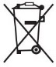
The symbol placed on the product indicates that it should not be considered as domestic waste, but must be correctly disposed of in order to prevent any negative consequences for the environment and the health of people. For further information on the recycling of this product, contact the local dealer or agent, the aftersales service or the local body responsible for waste disposal.
ATTENTION
Make the appliance unusable by removing the power cable and any compartment closing devices, to prevent the possibility of someone becoming trapped inside.

ATTENTION
When scrapping the machine, the data plate, this manual and other documents concerning the appliance must be destroyed.

