Ice Makers

Vertical Ice Cubes

Introduction
You have purchased one of the most reliable ice-making products on the market today.

Carefully read the instructions contained in this manual since they provide important information relative to safety during installation, use, and maintenance.

Warning
This appliance is intended to be used in household and similar applications such as staff kitchen areas in shops, offices and other working environments; farmhouses and by clients in hotels, motels and other residential type environments; bed and breakfast type environments; catering and similar non-retail applications.
The installation of this equipment should be done by the Service Department. The socket should always be placed on an accessible location.
When positioning the appliance, ensure the supply cord is not trapped or damaged.
Do not locate multiple portable socket-outlets or portable power supplies at the rear of the appliance. Always disconnect the power supply from the machine before any cleaning or maintenance service.
Any change needed on the electrical installation for the appropriate connection of the machine, should be exclusively performed by qualified and certified professional personnel only.
Any use by the ice maker not intended to produce ice, using potable water, is considered inappropriate. It is extremely dangerous to modify or intend to modify this machine and will void warranty.
The appliance is not to be used by persons (including children) with reduced physical, sensory or mental capabilities, or lack of experience and knowledge, unless they have been given supervision or instruction.
Children being supervised not to play with the appliance.
Connect to potable water supply only. To see “Installation” chapter (5). This machine is not intended to be used outdoors nor exposed to the rain.
The machine should be connected using the power cord supplied with the equipment.

It is mandatory to ground the equipment to avoid possible electric shock on individuals or damages to the equipment. The machine should be grounded pursuant local and/or national regulations. The manufacturer shall be held harmless in case of damages arising due to the lack of the ground installation. To see “Installation” chapter (7).

In order to assure the proper operation and efficiency of this equipment, it is extremely important to follow the recommendations of the manufacturer, especially those related to cleaning and maintenance operations, which should be performed by qualified personnel only.

CAUTION: The intervention of non-qualified personnel, besides of being dangerous, could result in serious malfunctioning. In case of damages, contact your distributor. We recommend always using original spare parts.

The company reserves the right to make changes in specifications and design without prior notice.
This signal indicates “Risk of fire / Flammable materials” because of the use of flammable refrigerant.
For compression-type appliances that use flammable refrigerants should additionally consider the substance of the warnings listed below:
- Keep ventilation openings, in the appliance enclosure or in the built-in structure, clear of obstruction.
- Do not use mechanical devices or other means to accelerate the defrosting process, other than those recommended by the manufacturer.
- Do not damage the refrigerant circuit.
- Do not use electrical appliances inside the food storage compartments of the appliance, unless they are of the type recommended by the manufacturer.

- Do not store explosive substances such as aerosol cans with a flammable propellant in this appliance. In case of a flammable refrigerant leakage:
- Do not generate flames close to the appliance.
- Do not switch on/off or plug in/off the appliance.
- To ventilate immediately the area where appliance is located by opening doors and/or windows.
- To call to an authorized technical service.
Disposal of the ice maker: The company encourages to follow the regulations of each country regarding eco- friendly disposal of electric and electronic devices such this one. User who is wanting to dispose of this equipment must contact the manufacturer and follow the method to appropriate differentiated collection for the subsequent treatments.

Reception of the Machine
Inspect the outside packing. In case of damages, MAKE THE CORRESPONDING CLAIM TO THE CARRIER. To confirm the existence of damages, UNPACK THE MACHINE IN THE PRESENCE OF THE CARRIER and state any damage on the equipment on the reception document or freight document.

Always state the machine number and model. This number is printed on three locations:
- Packing: On the outside, it contains a label with the manufacturing number.
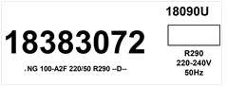

- Exterior of the equipment: On the back of the equipment, there appears a label with the same characteristics as the previous one.

- Nameplate: On the back of the machine.
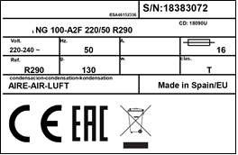

Check that in interior of the machine the installation kit is complete and comprises:

  - Scoop, drain hose, four legs and manual.
  - Water connection.
  - Warranty and serial number.

CAUTION: All packing elements (plastic bags, carton boxes and wood pallets) should be kept outside the reach of children, as they are a source of potential hazard.

Installation
1.- LOCATION OF ICE MACHINE

This ice maker is not designed for outdoor operation. The icemaker should not be located next to ovens, grills or other high heat producing equipment.

The machines are designed to operate at room temperature between 10ºC (41ºF) and 43ºC (109.4ºF). There may be some difficulties in ice slab removal under the minimum temperatures. Above the maximum temperature, the life of the compressor is shortened, and the production is substantially lower.

The air cooled (undercounter) ice makers take the air through the front section, and drive it off through the back and front louvers due to their new oblique condenser structure and placement. Do not place anything on the top of ice maker or facing the front grille. In case the front grille is either total or partially obstructed, or due to its placement it receives hot air from another device, we recommend, in case it is not possible to change the location or to install a water-cooled machine. The unit can be installed in a recessed position, with a reduction in production. The air cooled (modular) ice makers take the air through the back section and drive it off through the two lateral louvers. In the case it is not possible to respect the minimum distances recommended (see the picture in point 3) for these machines we recommend installing a water-cooled unit.

The location must allow enough clearance for water, drain and electrical connections in the rear of the ice machine. It is important that the water inlet piping do not pass near sources of heat so as not to lose ice production.

2.- LEVELING THE ICE MACHINE
Use a level on top of ice machine in order to ensure the equipment is perfectly levelled. Only for undercounter machines:
Screw the levelling legs onto the bottom of the ice machine as far as possible. Move the machine into its final position.
Use a level on top of the ice machine. Turn each foot as necessary to level the ice machine from front to back and side to side.
NOTE: An optional 3 1/2’’ (90mm) caster assembly is available for use in place of the legs. Installation instructions are supplied with the casters.
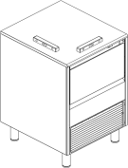
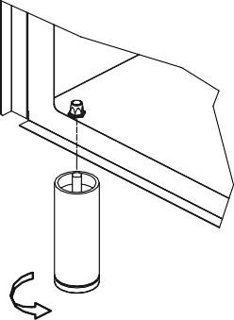

3.-MINIMUM DISTANCE TO OBSTACLES
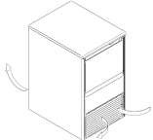
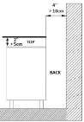
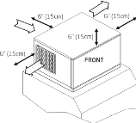
The minimum clearance values you can see below are recommended for efficient operation and servicing. UNDERCOUNTER MODELS MODULAR MODELS

4.-CONNECTION DIAGRAMS

The location must allow enough clearance for water drain and electrical connections in the rear of the ice machine.

UNDERCOUNTER MODELS MODULAR MODELS

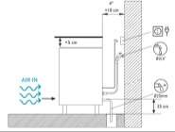
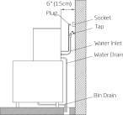

5.-WATER SUPPLY

The quality of the water supplied to the ice machine will have an impact on the time between cleanings and ultimately on the life of the product (mainly in water cooled units). It also will have a remarkable influence on the appearance, hardness and flavour of the ice.
Local water conditions may require treatment of the water to inhibit scale formation, improve taste and clarity. If you are installing a water filter system, refer to the installation instructions supplied with the filter system.
Pressure should be between 1 and 6 bar (0,1 MPa and 0,6 MPa or 14 and 85 psi). If pressure overpasses such values, install a pressure regulator.

ATTENTION: The machine shall be plumbed.

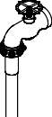
6.-DRAINAGE

Drainage should be located below the level of the machine, at 150 mm (5,9’’) minimum.
It is convenient that the drainage pipe is 30 mm (1,18’’) inside diameter and with a minimum gradient of 3 cm/ meter (0,36’’/ft), see figure below.

CORRECT INCORRECT

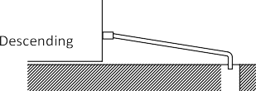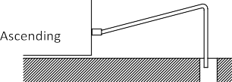

INCORRECT

7.-ELECTRICAL CONNECTION

IT IS MANDATORY TO GROUND THE EQUIPMENT: To avoid possible discharges on individuals or damages to the equipment, the machine should be grounded following local and/or national regulations as needed. THE MANUFACTURER SHALL BE HELD HARMLESS IN CASE OF DAMAGES ARISING DUE TO THE LACK OF THE GROUND INSTALLATION.

In case the supply cable is damaged, it should be replaced by a cable of special assembly to be furnished by the manufacturer or after-sales service. Such replacement should be performed by qualified technical service only. The machine should be placed in such a way that allows a minimum space between the back and the wall to allow an easy access and without risks to the cable plug.

It is convenient to install adequate switches and circuit breakers.

Voltage is indicated in the nameplate. Variation on voltage above the 10% stated on the nameplate could result on damages or prevent the machine start-up.

8.-INSTALLATION OF MODULAR EQUIPMENTS ON TOP OF BINS

Modular ice makers should be installed on top of bins, following the instructions contained in this manual.
The resistance and stability of the container-machine/s assembly should be verified, as well as the fastening elements. Follow bin manufacturer instructions.

Start-Up

1.- Previous Checkup
- Is the machine levelled?
- Voltage and frequency are the same as those on the nameplate?
- Are the discharges connected and operating?
- Will the ambient temperature and water temperature remain in the following range?

 | ROOM |  | WATER
MAXIMUM | 43º C | / 109º F | 35ºC | / 95º F
MINIMUM | 10º C | / 43º F | 5ºC | / 35º F

- Is water pressure appropriate?

MINIMUM | 1 Bar (0,1 MPa or 14 psig)
MAXIMUM | 6 Bar (0,6 MPa or 85 psig)

NOTE: In case input water pressure is higher than 6 Bar (0,6 MPa or 85 psig), install a pressure regulator.

2.- Start-Up
Once the installation instructions are followed (ventilation, site conditions, temperatures, water quality, etc.), proceed as follows:
  - Open the water inlet. Verify the no existence of leakages.
  - For undercounter models open the door and remove the protection elements on the shield. For modular models remove the two locking screws on top of machine, take off the front panel and remove protection elements on the shield and on the thickness sensor.
  - Verify that the shield moves freely. For modular models verify also the thickness sensor moves freely.
  - Connect the machine to the power supply.
  - For undercounter models: push the switch on the machine front side. For modular models: push the switch found on the back of the machine and then set the ice-wash switch to the position I.
  - Verify that there are no vibrations or frictions on the elements.
  - Verify that the water fall to the evaporator is occurring uniformly and all ice cubes are properly watered.
  - Close door (for undercounter models) / Replace the front panel in its place (for modular models).
  - For modular models verify the ice slab with the pictures below through the thickness sensor which needs to be regulated. In case of undercounter models, to adjust the switches according to tables shown on the label placed on top cover

Modular Models Undercounter Models

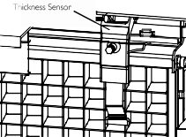

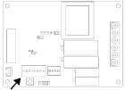
Damages due to the lack of maintenance and cleaning operations are not included on the warranty.

3.- Sequence of Operation
- Initial Start-up: The first time the machine is started there is a delay of 30“in the power on sequence, it begins with the harvest sequence to ensure the water tray is filled.
- Freeze sequence: The compressor is energized. The water circulates from the water tray to the upper distributor, flowing through each cube cell, where it freezes. In undercounter models the freezing time is a programmed time, can be adjusted following the previously indicated table. For modular models this time depends on thickness sensor adjustment.
- Harvest sequence: The hot gas valve is opened and at the same time energizes the water inlet valve during a certain time to fill the water tray with the appropriate quantity of water. The ice slab slides off the evaporator and falls into the bin. Curtain opening finishes harvest step. After this, the freeze sequence starts again.
- When storage bin is full, the ice slab cannot fall down and curtains remains opened. The machine shuts off until enough ice has been removed from the storage bin and the curtain close again.

Maintenance and Cleaning Procedures

It is the User’s responsibility to keep the ice machine and ice storage bin in a sanitary condition.
Ice machines also require occasional cleaning of their water systems with a specifically designed chemical. This chemical dissolves mineral build up that forms during the ice making process.
Sanitize the ice storage bin as frequently as local health codes require, and every time the ice machine is cleaned and sanitized.
The ice machine’s water system should be cleaned and sanitized at least twice a year. CAUTION: Do not mix Ice Machine Cleaner and Sanitizer solutions together.
WARNING: Wear rubber gloves and safety goggles when handling Ice Machine Cleaner or Sanitizer. WARNING: Unit should always be disconnected during maintenance/cleaning procedures.
CLEANING WATER DISTRIBUTION SYSTEM

- Cleaning Water Distribution System for Undercounter Models

  - Set the switch to the OFF position after ice falls from the evaporator at the end of a harvest cycle or set the switch to the OFF position and allow the ice to melt off the evaporator.
CAUTION: Never use anything to force ice from the evaporator.
  - Remove the back metal lid and the top panel (if it need be to make easier the cleaning operations).

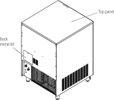
  - Remove all ice from the bin.
  - Remove the auxiliary pipe for drain operations near the pump and empty the water tray. Return it to their original position to avoid water spill.
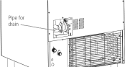

  - Prepare a solution of an appropriate product for the cleaning of ice machines (lime). Do not use hydrochloric acid. We recommend the use of any food approved scale removal product prepared according to the manufacturer’s instructions.
  - Fill water tray with the solution.
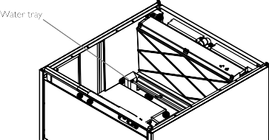

  - Switch on the machine while keeping pressed the wash button behind the front grid in order to run water pump. Let solution stand for 30-40 minutes and then switch off the machine.
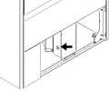

  - Disconnect power and water supplies.
  - Remove the auxiliary pipe to drain and purge out the ice machine scale remover and residue. Replace it.
  - Mix enough cleaning solution (as in point 5) to clean parts and interior food zone surfaces.
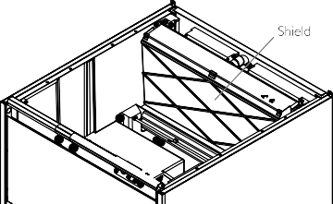
  - Remove shield.

  - Clean all surfaces of the shield with the cleaner solution using a brush (not a wire brush) or cloth. Rinse all areas with water.
  - Clean all the interior surfaces of the freezing compartment (including storage bin) with the cleaner solution using a brush or cloth. Rinse all areas with water.
  - Mix a solution of sanitizer using approved (EPA/FDA) sodium hypochlorite food equipment sanitizer to form a solution with 100 - 200 ppm free chlorine yield.
  - Sanitize all surfaces of the shield applying liberally the sanitizer solution using a cloth or sponge.
  - Sanitize all the interior surfaces of the freezing compartment (including the storage bin) applying liberally sanitizer solution, using a cloth or sponge.
  - Return shield to its position.
  - Connect power and water supplies.
  - Fill water reservoir with the sanitizer solution.
  - Repeat point 7 in order to run water pump. Let solution stand for 20 minutes and switch off.
  - Remove the auxiliary pipe to drain and purge out the sanitizer solution and residue. Replace it. Fill the water reservoir with water and switch on the machine to allow water to circulate for 5 minutes and then stop the machine. Repeat this operation two more times to rinse thoroughly.
  - Remove the auxiliary hose to drain the water. Replace it and fill the tray with water to ensure the pump works properly.
  - Return the back metal lid and the top panel to their position.
  - Switch on machine and discard the first two harvests.

CLEANING THE ICE BIN (FOR UNDERCOUNTER MODELS)

- Disconnect the machine, close water faucet and empty storage bin of ice
- Use the cleaner/water solution to clean all surfaces of the bin. Use a nylon brush or cloth. Then rinse all areas thoroughly with clean water.
- Use the sanitizer/water solution to sanitize all surfaces of the bin. Use a nylon brush or cloth.
- Rinse with plenty of water, dry, run the machine and open water faucet.

CLEANING THE CONDENSER (FOR UNDERCOUNTER & MODULAR MODELS)

- Air Condenser

  - Disconnect machine and close water faucet.
  - For undercounter models remove the front grid by pressing the two clips placed at right side. For modular models remove the back panel (see figures below).
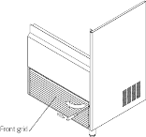
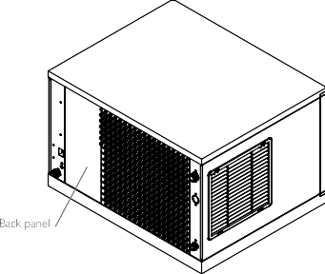

  - Clean condenser using a vacuum cleaner, soft brush or low pressure air. Clean from top to bottom, not side to side. Be careful not to bend the condenser fins.

- Water Condenser

The water condenser may require cleaning due to scale build-up. The cleaning procedures require special pumps and cleaning solutions. They must be performed by qualified maintenance or service personnel.

CLEANING THE OUTSIDE OF THE MACHINE

Clean the area around the ice machine as often as necessary to maintain cleanliness. Sponge any dust and dirt off the outside of the ice machine with mild soap and water. Wipe dry with a clean soft cloth. A commercial grade stainless steel cleaner/polish can be used as necessary.

CHECKING FOR WATER LEAKS

This must be done whenever maintenance is carried out on the machine: check all water connexions, braces, tubes and hoses in order to eliminate leaks and prevent breakages and flooding.

- Cleaning Water Distribution System for Modular Models

  - Set the switch to the OFF position after ice falls from the evaporator at the end of a harvest cycle or set the switch to the OFF position and allow the ice to melt off the evaporator. Set Ice-wash switch to the OFF position (position 0) after ice falls from the evaporator at the end of a harvest cycle, or set the ice- wash switch to the OFF position and allow the ice to melt off the evaporator.
CAUTION: Never use anything to force ice from the evaporator. Damage may result.

  - Remove the front panel.
  - Prepare a solution of an appropriate product for the cleaning of ice machines (lime). Do not use hydrochloric acid. We recommend the use of any NSF approved scale removal product. In modular machines the water bucket is filled automatically so we recommend to prepare a previous solution (for example 0.15L) according to the manufacturer’s instructions with the total quantity of product needed for the water tray.
  - To start a cleaning cycle, move the ice-wash switch to the WASH position (position II). The machine will drain the reservoir and refill it. Pour the scale remover solution into the reservoir.
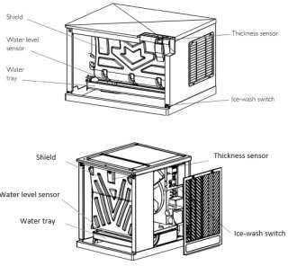

  - Allow the solution to circulate in the water system for 30-40 minutes and then set the ice-wash switch to the OFF position.
  - To purge out the ice machine scale remover and residue move the ice-wash switch to the WASH (the machine will drain the reservoir and refill it) and then set the ice-wash switch to the OFF position.
  - Disconnect power and water supplies.
  - Mix a cleaning solution.
  - Remove the water pump, the curtain and the water tank.
Clean the metal surfaces, thickness sensor, water level sensor, adjusting screw, water pump electrode, curtain and water tank with the cleaning solution using a brush (not a wire brush). ) or cloth.
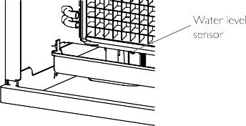
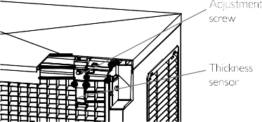
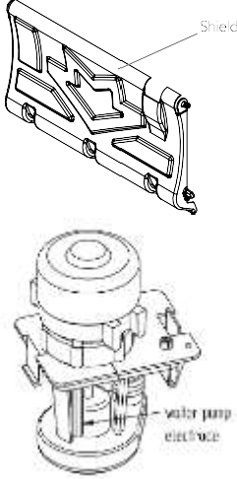
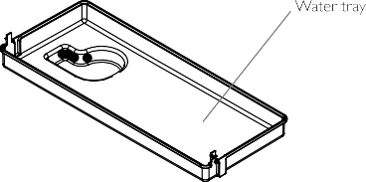

  - Clean the interior surfaces of the freezing compartment (including walls, plastic parts of the evaporator, distributor...) and the front panel with the cleaner solution using a brush or cloth.
  - Mix a solution of sanitizer using approved (EPA/FDA) sodium hypochlorite food equipment sanitizer to form a solution with 100 to 200 ppm free chlorine yield.
  - Disinfect all the surfaces of the thickness detector, the water level detector, the electrode of the water pump, the curtain and the water tank by applying abundant solution using a cloth or sponge.
  - Sanitize the interior surfaces of the freezing compartment (including walls, plastic parts of the evaporator, distributor...) and the front panel applying liberally the sanitizer solution using a cloth or sponge.
  - Return the water pump, water tank and curtain to their normal position.
  - Connect power and water supplies.

  - To start a sanitation cleaning cycle, move the ice-wash switch to the WASH position. The machine will drain the reservoir and refill it. Pour the sanitizer into the water reservoir to get a solution as in the point 12.
  - Allow the solution to circulate in the water system for 20 minutes and then set the ice-wash switch to the OFF position.
  - To purge out the sanitizer solution and residue move the ice-wash switch to the WASH position (drain and refill) and allow the water to circulate for 5 minutes and then move the switch to the OFF position (drain). Repeat this operation two more times to rinse thoroughly.
  - Return the panel to their position.
  - Set the ice-wash switch to the ON position (position I) and discard the first two harvests.

User Troubleshooting Guide
UNDERCOUNTER MODELS:

PROBLEM | PROBABLE CAUSE | SOLUTION
None of the electrical parts work. | The machine is unplugged. | Plug in the machine and verify shocket power.
 | Curtain not properly closed | Check no ice and it moves freely
No water in tray. | Not incoming water. | Check water supply.
 | Inlet strain at water valve blocked. | Check an clean.
Ice slab empty or too thick. | Disadjusted cycle time. | Adjust PCB switches
Difficult to release ice slab at harvest. | Unit bad leveled (tilted to back). | Level; down front.
Not uniform flow pattern at evaporator. | Dirty or scaled distributor. | Perform descaling procedure. Remove and clean distributor (pull from two clips at distributor sides).
Unit run and stops alternatively itself | Safety presostat opens. | Clean air condenser (behind front grid).

MODULAR MODELS:

